**Project Report**

Software Engineering UCS503



Notes Sharing Website

Prepared by : Team Pixel

# Arshdeep Palial 102216099

# Pranav Duggal 102216023

# Jaskaran Singh 102216110

# Tarun Bhatti 102216105

**Software Bid/ Project Teams**

**UCS 503- Software Engineering Lab**

Group : CS14 , CS11 Dated: 27/1/2024

**Team Name: PIXEL**

**Team ID (will be assigned by Instructor):**

Please enter the names of your Preferred Team Members.

*You are required to form **a three to four person** teams

*Choose your team members wisely. You will not be allowed to change teams.

|  |  |  |  |
| --- | --- | --- | --- |
| Name | Roll No | Project Experience | Programming  Language used |
| ARSHDEEP PALIAL | 10216099 | FULL STACK WEB APPS , BASIC GAMES ,  ARDUINO IOT PROJECTS | PYTHON, REACTJS  , C/C++ |
| TARUN BHATTI | 102216105 | FORNTEND DESIGNS FOR WEB APPS | JS , JQUERY |
| PRANAV DUGGAL | 102216023 | WEB AND ANDROID APPLICATIONS | REACTJS,FLUTTER |
| JASKARAN SINGH | 102216110 | FORNTEND DESIGNS FOR WEB APPS | JS , JQUERY |

**Programming Language / Environment Experience**

List the languages you are most comfortable developing in, **as a team**, in your order of preference. Many of the projects involve Java or C/C++ programming.

1. Python
2. JavaScript
3. C/C++

**Choices of Projects:**

Please select **4 projects** your team would like to work on, by order of preference: *[Write at-least one paragraph for each choice (motivation, reason for choice, feasibility analysis, etc.)]*

|  |  |
| --- | --- |
| First Choice | A WEB APP TO PROVIDE , CONNECT AND GUIDE STUDENTS . |
| Second Choice | A WEB APP TO CONNECT EVERY STUDENT IN COLLEGE . |
| Third Choice | HOSPITAL MANAGEMENT. |
| Fourth Choice | ECOMMERECE WEBSITE. |

**Additional Remarks/ Inputs**

Please tell us about any other factors that we should take into consideration (e.g., if you really would like to work on a project for some particularly convincing reason).

Web app to provide, connect and guide students.

Helping students by

* PROVIDE -The app provides students with notes uploaded by authorized individuals. Student ratings ensure the quality and relevance of the notes.

* Connect - Experience a new level of social interaction! Connect with students from different branches and widen your social circle with just a few taps.

* Guide - Guiding light for students, helping them to learn the skills they need to achieve a brighter future.

**Project Write Up**

**NOTO**

**Team Pixel**

**Executive Summary:Note Sharing Website Project**

**Noto** is a revolutionary web-based platform that transforms notes sharing into a visually stimulating and collaborative experience. Inspired by the familiar and engaging interface of Instagram, Noto empowers students to learn , share , communicate using captivating and simple interface.

**Problem:**

**Problems with Traditional Studying:**

**Isolation:** Studying feels like a solitary activity, leading to a lack of motivation and engagement.

**Inefficiency:** Traditional note-taking methods can be time-consuming and result in disorganized information.

**Limited Perspective:** Students may rely solely on their own notes, which might not be the most comprehensive or effective.

**Difficulty Finding Study Partners:** Students might not know the right people to connect with to form study groups.

**Solutions Offered by Noto:**

**Social Learning:** Connect with classmates and study partners, fostering a collaborative and motivating learning environment.

**Visually Engaging Notes:** Create visually appealing notes with images, diagrams, and creative layouts to boost information retention.

**Community-Sourced Knowledge:** Explore a vast library of notes shared by other students, gaining access to diverse perspectives and valuable resources.

**Streamlined Organization:** Categorize notes with relevant hashtags for easy retrieval and efficient studying.

**Novelty/ Unique Selling Point :**

**USP 1**: **The Social Clipboard** - Noto fuses the visual engagement of Instagram with the collaborative power of shared study materials, creating a vibrant social space where students can learn from each other and boost their academic performance.

**USP 2**: **Take Control:** Noto empowers students to actively curate their own learning experience by selecting the best resources and collaborating with peers. It's not just passive consumption, but active engagement in the learning process.

**Objectives :**

**Enhance Student Engagement:** Transform note-taking from a solitary chore into a visually stimulating and socially interactive experience. This fosters deeper understanding and motivates students to actively participate in the learning process.

**Promote Collaborative Learning:** Facilitate seamless sharing of notes and resources between classmates. Encourage discussions and feedback through comments and mentions, fostering a supportive learning community.

**Elevate Note-Taking Practices:** Move beyond plain text notes. Encourage students to utilize images, diagrams, and creative layouts to create visually engaging and memorable study materials.

**Empower Knowledge Discovery:** Build a vast library of user-generated notes, categorized by hashtags and searchable for easy access. This allows students to discover diverse perspectives, find valuable resources, and fill any gaps in their own understanding.

**Streamline Organization and Retrieval**: Implement a user-friendly system for categorizing notes with relevant hashtags. This allows for efficient searching and retrieval, saving students valuable time during their studies.

**Project Deliverables/Outcomes:**

1. **An Note Sharing Website** - Web based platform accessible to students and the teachers.
2. **Documentation** - Software bid, Project write up, Feasibility report, UML diagrams, SRS, Project report.

**Product Perspective: Noto**

**Stakeholders:**

* **Primary:** Students (of all ages and disciplines)
* **Secondary:** Educators, Professionals

**Product Vision:**

* To revolutionize student learning by creating a visually engaging, collaborative platform for note-taking, knowledge sharing, and community building.

**User Needs:**

* **Students:**

* Capture and organize information effectively (visually appealing notes, hashtags for searchability).
* Collaborate with peers (share notes, discuss concepts, find study partners).
* Access diverse learning resources (explore public notes, discover different perspectives).
* Enhance information retention (visually-driven content, engaging learning environment).

* **Educators:**

* Facilitate student engagement (encourage active learning through visuallydriven notes).
* Promote collaborative learning (provide a platform for students to share resources and discuss concepts).
* Monitor student progress (access to student-generated notes, gauge understanding through discussion threads).
* Learn and upskill efficiently (access to user-generated content, discover best practices).
* Connect with like-minded individuals (build professional networks, share industry knowledge).

* **Product Features:**

* **Seamless sharing:** Share notes privately with study groups or publicly for wider access.
* **Public note discovery:** Explore a vast library of public notes shared by other users.
* **Number of active users:** Students, educators, and professionals using the platform.
* **Community growth:** Number of connections formed, active discussion threads, collaborative learning initiatives.
* **Knowledge discovery:** Frequency of searches, utilization of public notes, positive feedback on resource availability.
* **Scalability and Flexibility:** The platform is designed to be scalable and flexible, allowing small business owners to adapt and expand their online stores as their businesses grow. This includes features such as customizable pricing plans, and the ability to add new products and features as needed.

**Noto: Look and Feel**

**Concept:**

Noto draws inspiration from the familiar and user-friendly interface of Instagram, but tailors it specifically for the needs of note-taking and knowledge sharing. The overall aesthetic should be:

**Visually Appealing:** Leverage bright colors, clean layouts, and high-quality visuals to create an engaging experience.

**Modern and Minimalist:** Prioritize clean lines, intuitive navigation, and easytounderstand icons and buttons.

**Social and Collaborative:** Emphasize user profiles, connections, and features that encourage interaction between users.

**Key Design Elements**:

**Home Feed:** The main screen displays a curated feed of notes shared by users you follow and relevant public notes based on your interests and hashtags. Each note appears like a "post" with a visually captivating image preview, a short caption, and engagement options (likes, comments).

**Note Creation:** Creating a note resembles creating a new post on Instagram. Users can upload images, diagrams, or screenshots, add text overlays for explanations, and include relevant hashtags.

**Profile Section:** Users can personalize their profiles with a profile picture, a short bio, and links to their social media (optional). The profile also displays their uploaded notes, the number of followers and following, and badges earned (if a gamification element is implemented).

**Search Function:** A powerful search bar allows users to find specific notes using keywords and hashtags. Search results display relevant notes along with user profiles and relevant subject tags.

**Navigation:** A clear and intuitive navigation bar at the bottom of the screen provides easy access to the home feed, search function, profile section, and potentially a messaging or notification section.

**Scope of Application**

**Higher Education:** College and university students can create visually-driven lecture notes, collaborate on group projects, and discover study resources shared by peers. Professors can use Noto to share course materials, facilitate online discussions, and encourage peer learning.

**Online Learning Platforms:** Noto can integrate with online learning platforms to provide students with a collaborative note-taking and knowledge sharing tool. This can be particularly beneficial for self-paced learning courses.

**Professional Development:** Professionals can use Noto to capture key takeaways from training sessions, share industry best practices, and collaborate on ongoing learning initiatives.

**Gant Chart for project**

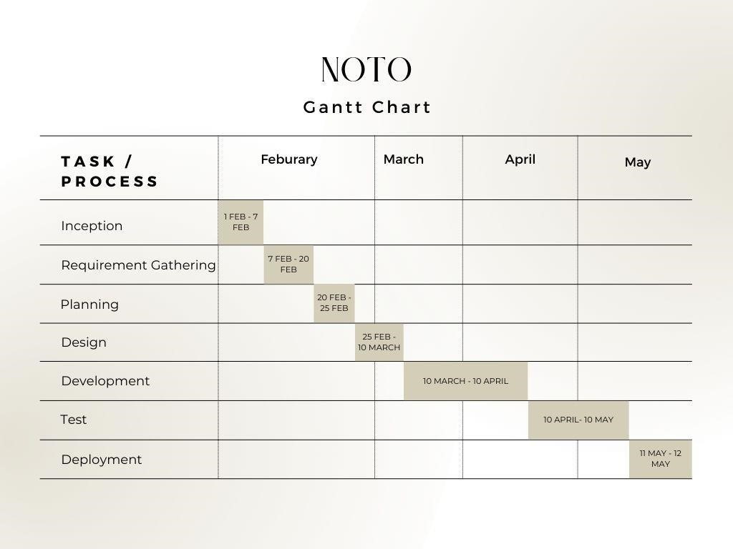

**UI/UX Design**

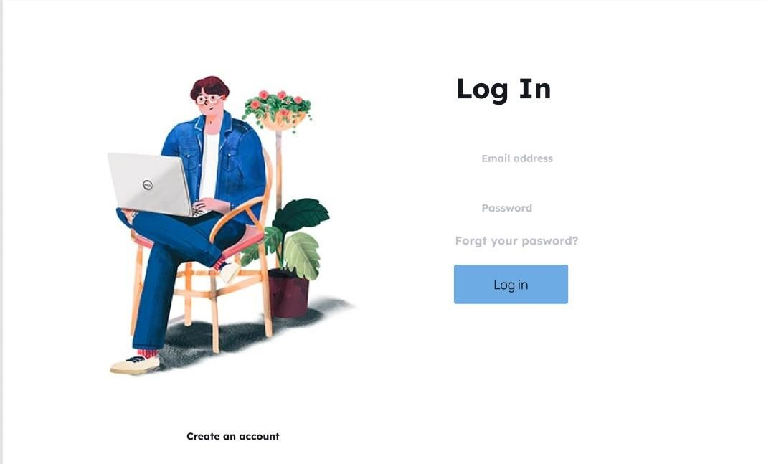

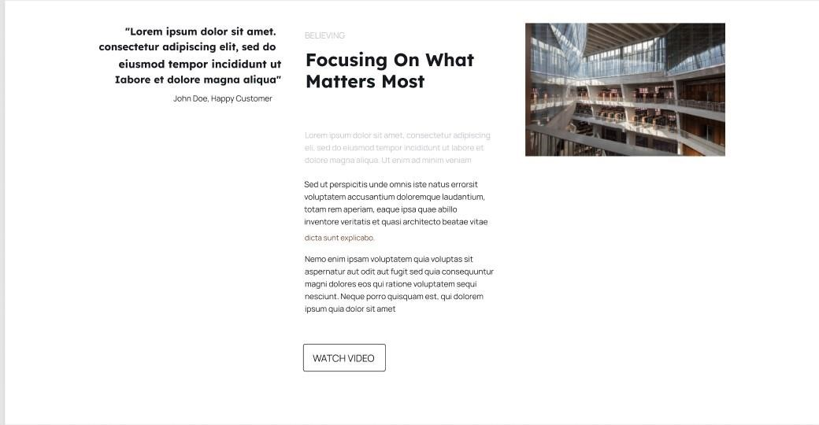

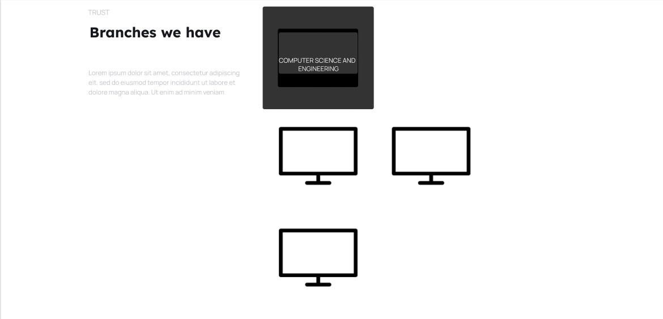

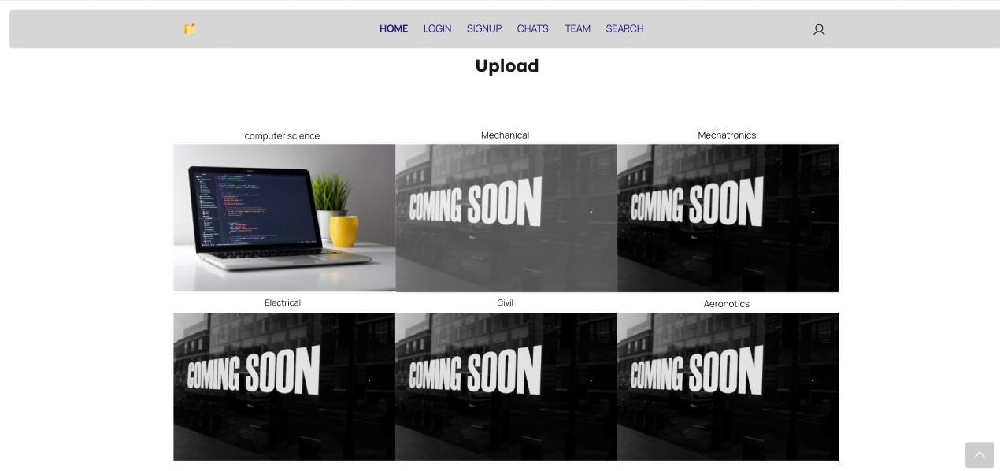

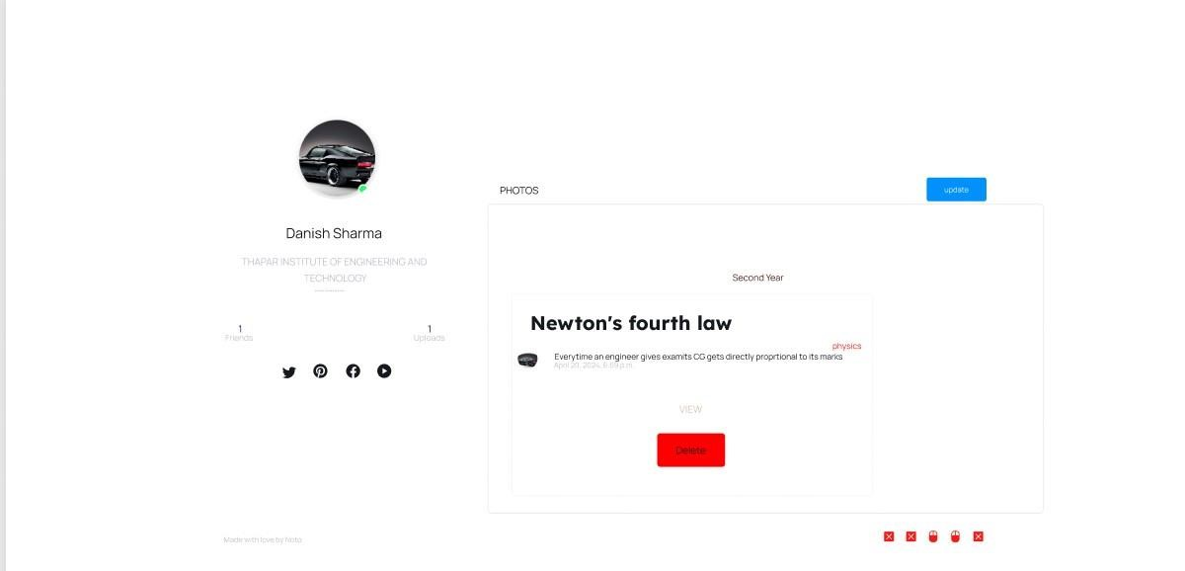

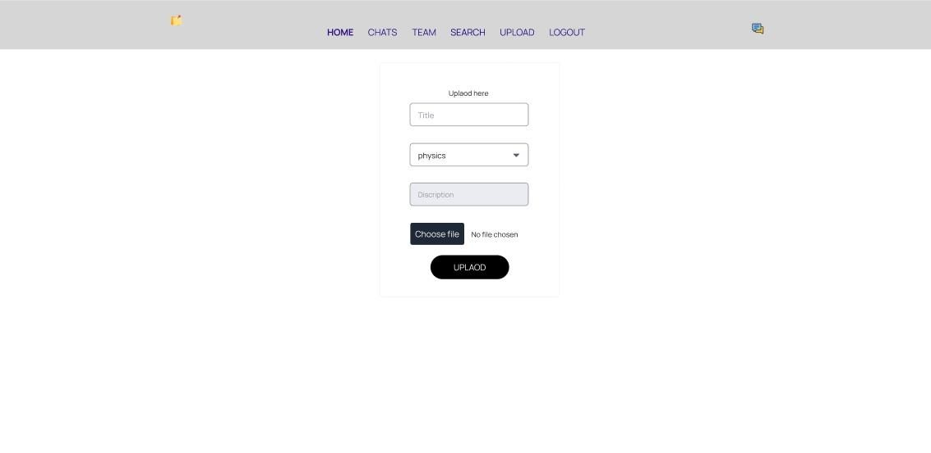

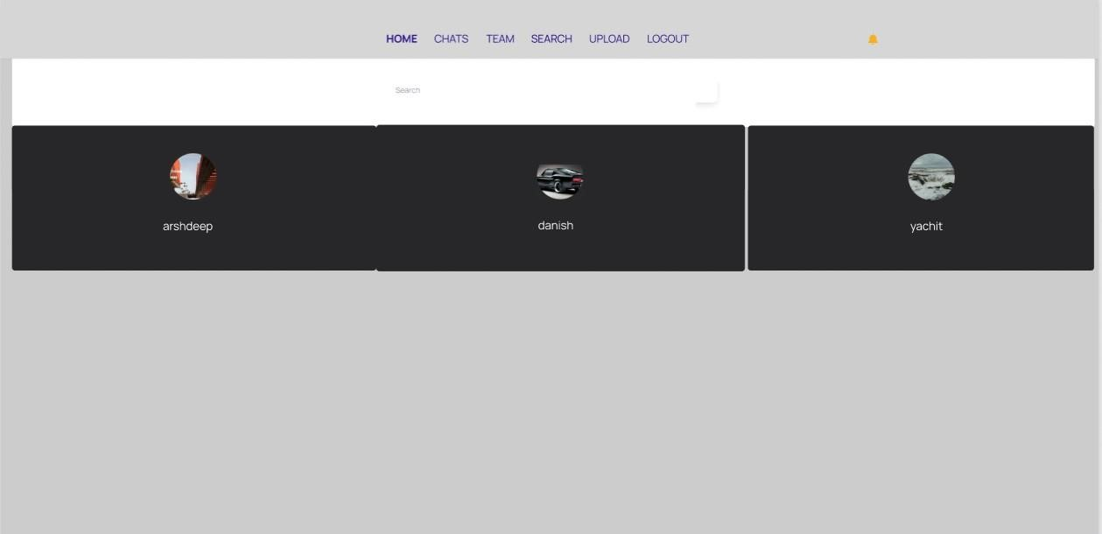

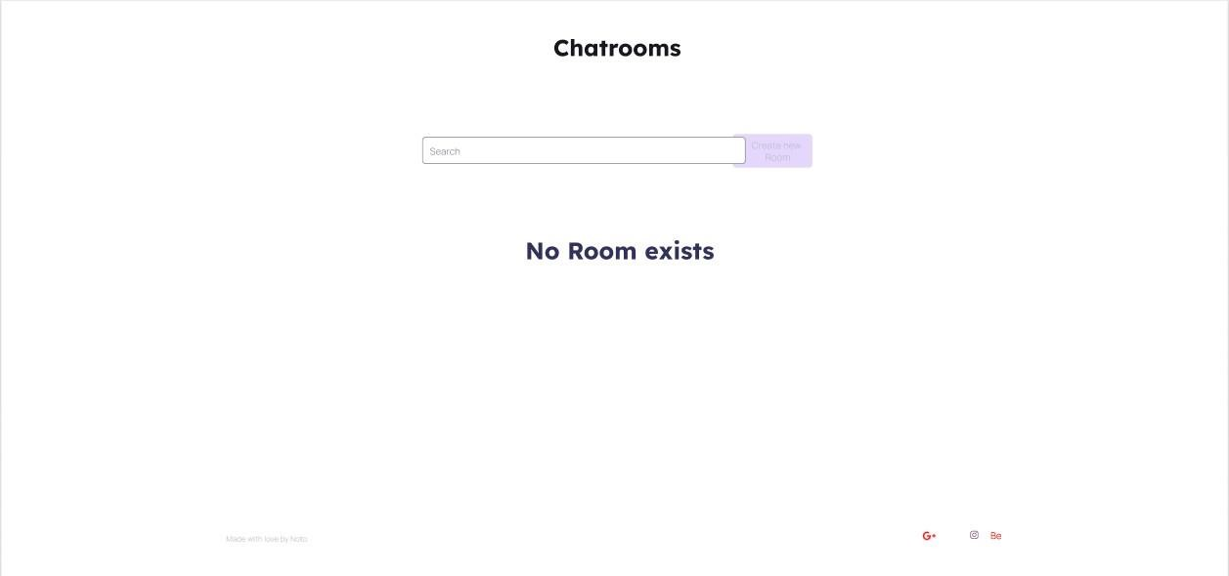

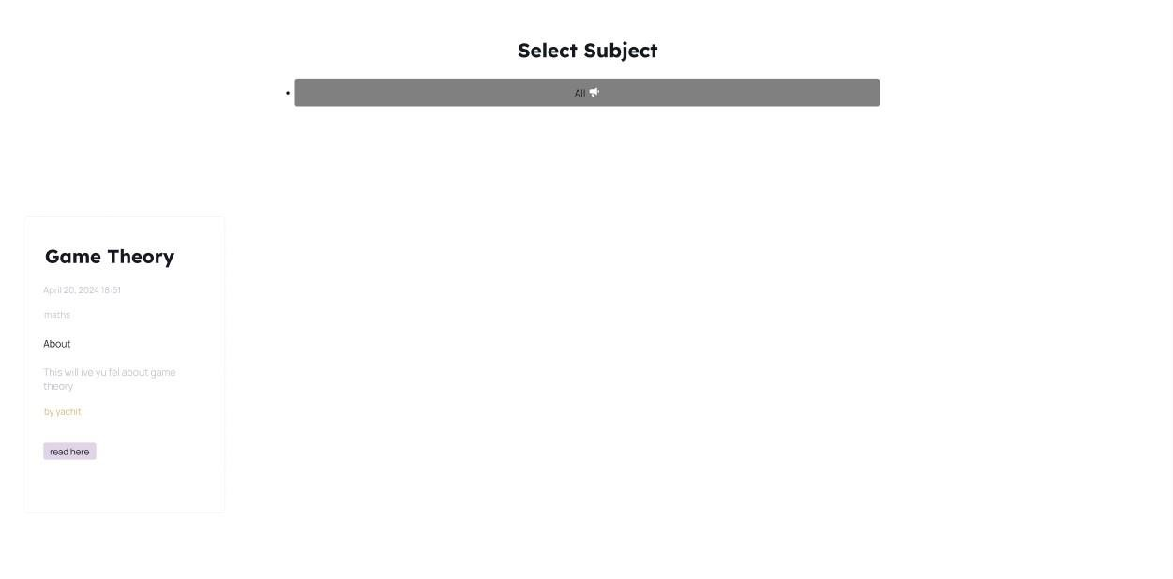

**Software Requirements**

**Specification**

# for

**Notes Sharing Website**

**Prepared by Team Pixel**

***Software Requirements Specification for Notes Sharing Website***

***Page 2***

**Table of Contents**

## **1. Introduction 1**

**1.1 Purpose 1**  **1.2 Document Conventions 1**  **1.3 Intended Audience and Reading Suggestions 1**

## **2. Overall Description 2**

### 2.1 UML Diagram/User Classes and Characteristics 2 2.2 Operating Environment 2 2.3 Design and Implementation Constraints 2

|  |  |
| --- | --- |
| 1. **System Features 3**     1. **Features for guest Users 3**    2. **Features for Registered Students 4** | |
|  |  |
| 1. **External Interface Requirements**     1. **User Interfaces 4**    2. **Software Interfaces 4** | **4** |
| 1. **Other Nonfunctional Requirements**     1. **Performance Requirements 5**    2. **Safety Requirements 5**    3. **Security Requirements 5** | **5** |
| **5.4 Software Quality Attributes** | **5** |

## **1. Introduction**

### Purpose

*This document outlines the requirements for a web application, codenamed "Noto" designed to function as a question-and-answer platform specifically for university students and their coursework.*

### Document Conventions

*The functional requirements for this project are organized by use case within use case with user class.*

### Intended Audience and Reading Suggestions

*Noto will be a web-based platform where students can ask questions related to their academic subjects, courses, assignments, and other university-related topics. The platform will foster a*

*collaborative learning environment by allowing other students and verified educators to answer questions and provide explanations.*

## **2. Overall Description**

### User Classes and Characteristics: UML Use Case Diagram

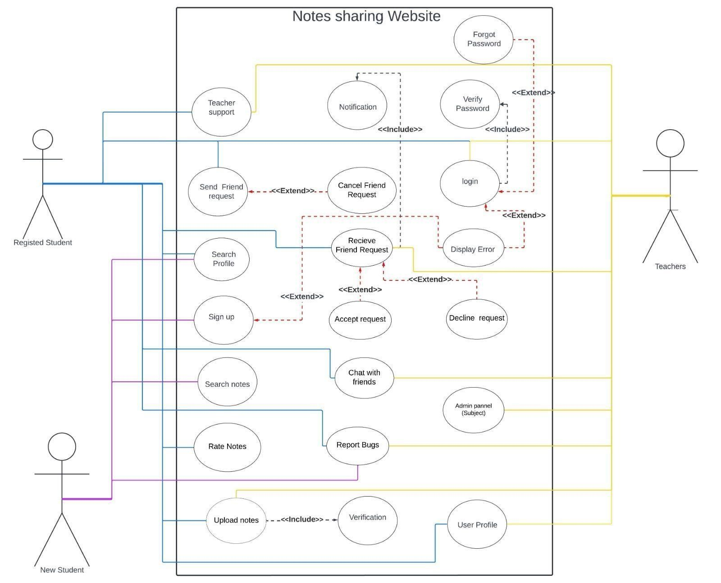

### Operating Environment

*Noto will be a web-based platform and shall be compatible with web browsers on windows and mac and web enabled smartphones.*

### Design and Implementation Constraints

CO-1: The Administrator shall be able to maintain and modify the site without requiring any specialized technical knowledge beyond basic HTML or the use of site editing tools provided by a commercial web site builder, such as WordPress.

CO-2: The website shall be developed using the Java platform and design using HTML, CSS, and JS.

CO-3: The Backend of the website shall be developed using python framework Django.

### User Documentation

The developer shall provide necessary documentation to enable an Administrator to perform the use cases listed in section 2.1.4 Administrator.

### UML Class Diagram

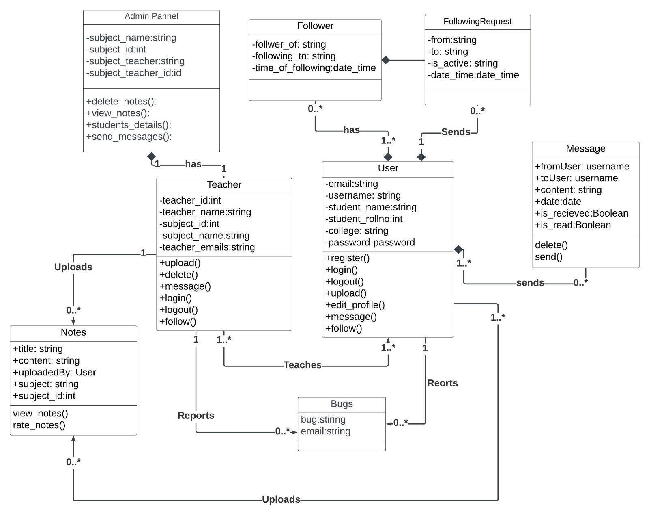

### Activity diagram

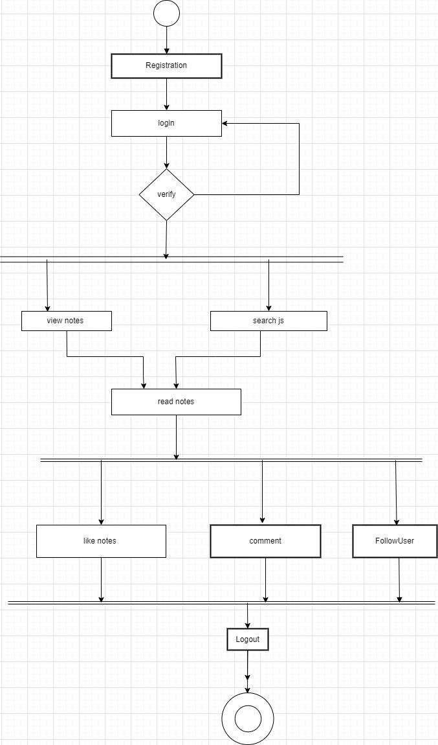

### Activity Swimlane

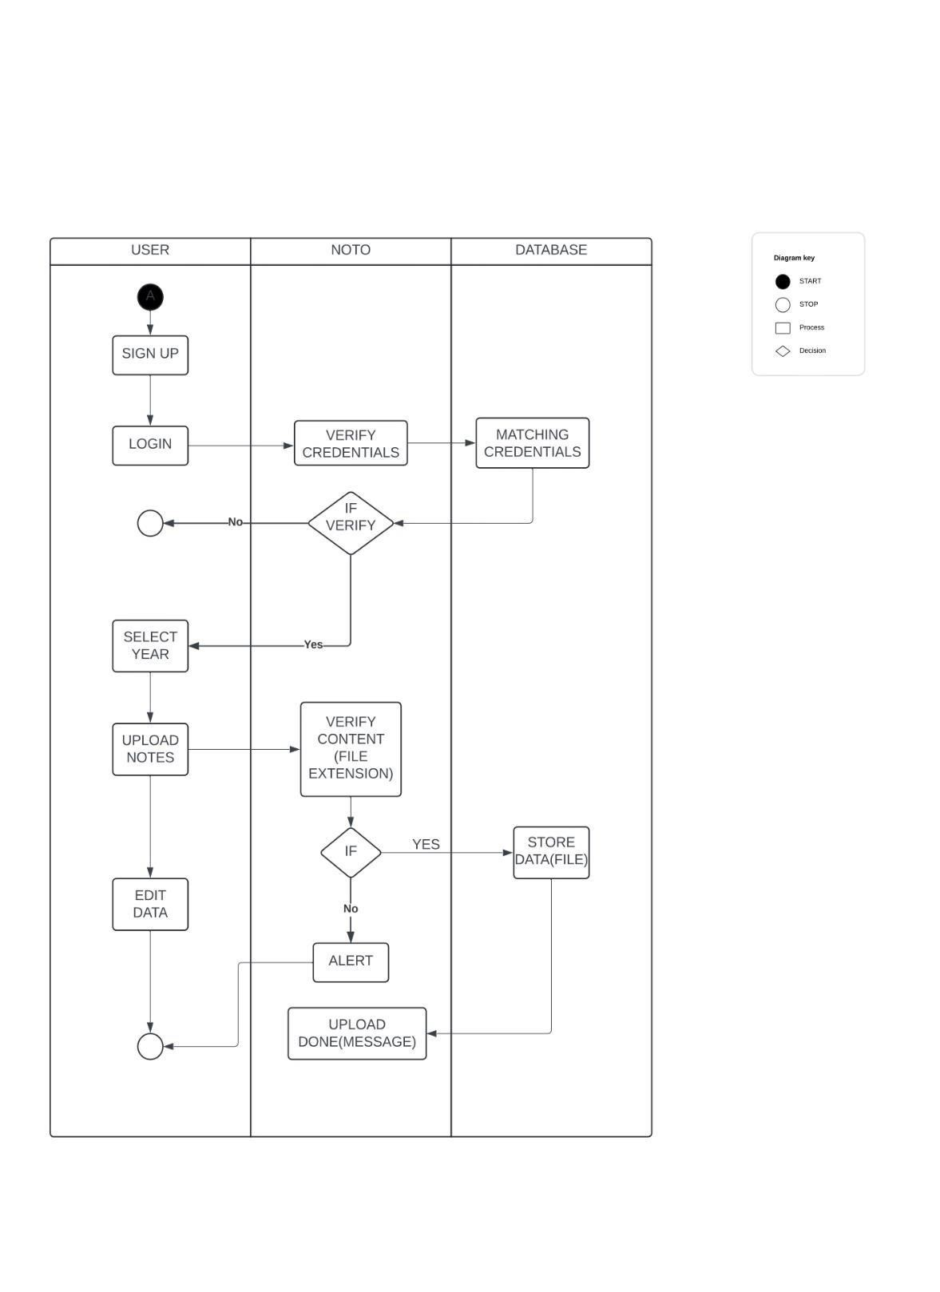

## **3. System Features/Use Case Details**

### Use Cases for Guest

#### UC-G-1: Login to system

Description: A guest shall be able to login to the system to do more actions.

Login form: A Guest shall be able to login to the system by entering their (Priority=H) email address and password that are available in the system accounts list to the form.

Login method: A Guest shall be allowed to login by connecting with a facebook (Priority=H) account or a gmail account.

Login recaptcha: A Guest shall check re-CAPTCHA to confirm that it is a human (Priority=H) being.

Login recaptcha If a Guest doesn't check re-CAPTCHA, the website shall display (Priority=H) an error message. error:

Login valid account: The application shall display an error message if the Guest (Priority=H) enters invalid email address or password that is not available in the system account list.

Login redirect verify: If a Guest enters an account that is inactive, the application shall (Priority=H) redirect the guest to a verified page.

Login verify: The Guest shall enter a code that the system has sent to their (Priority=H) email.

Login verify error: If a Guest enters an invalid verified code, the application shall (Proprity=H) display an error message. A code may be invalid because the code doesn’t match the code in a guest’s email.

Login redirect home: The application shall redirect a user to home if a user enters a (Priority=H) valid account that has been verified and already checked reCAPTCHA. After login, the user may be a customer or an admin depending on their role and their using environment.

#### UC-G-2: Register

Register form: A Guest shall be able to create new account by entering email (Priority=H) address, password and confirm password and other information such as first name, last name, address, phone

.

|  |  |
| --- | --- |
| Register valid email: The application shall display an error message if the e-mail (Priority=H)  address that the Guest enters is missing or not properly | |
| formatted. A valid e-mail address contains only letters and numbers, must contain exactly one “@” following one or more characters, must contain exactly one period following the “@” with any number of intervening characters, and must have at least one character following the period.  Register valid email: The application shall display an error message if the e-mail address that the Guest enters is missing or not properly formatted. A valid e-mail address contains only letters and numbers, must contain exactly one “@” following one or more characters, must contain exactly one period following the “@” with any number of intervening characters, and must have at least one character following the period  .  Register valid The application shall display an error message if the password is not matched with the proposed format of the application,  password that would be more than 6 characters and included: word,  number and special characters (like @, #, $...)    Register valid The website shall display an error message if a guest doesn’t confirm: enter the confirm password that doesn’t match the password.    Register valid field: The website shall display error messages if any text fields are empty.  The application shall display an error message if the guest  enters invalid email address or password that is not available in the system account list.    Register method: A Guest shall be able to sign up by connecting with a facebook account or a gmail account. | (Priority=H)  (Priority=H)  (Priority=H)  (Priority=H)  (Priority=H)  (Priority=H) |
| Register send: The application shall send the verified code via email to a guest’s (Priority=H) email.    Register redirect The application shall redirect a guest to login form if a guest (Priority=H) login creates a new account successfully. | |

#### UC-G-4: View information details for th Notes

Notes detail view: A Guest that on customer site shall be able to view detail of a car (Priority=H) such as notes name, seats, feedbacks,…

#### UC-G-5: Search Notes

Notes search: A Guest that on customer site shall be able to search available (Priority=H) cars by entering notes name or choosing notes type, notes quantity, rental date and return date.

### Use Cases for Authenticated User

**UC-AU-1: Logout**

Description: An Authenticated User shall be able to logout application.

#### UC-AU-2: Change password

Description: An Authenticated User shall be able change his password. The application shall display an error message if he entered the wrong previous password or invalid new password field.

*Constraint: The valid password must be more than 6 characters and contains at least one word, one number and one special character (like @, #, $ …)*

#### UC-AU-3: Manage profile

Description: An Authenticated User shall be able to manage his profile.

|  |  |
| --- | --- |
| Profile avatar add: | An Authenticated Usershall be able to add an (Priority=L) avatar to profile. |
| Profile add error: | If an Authenticated User add an image that (Priority=L) bigger than 900 x 900, the application shall display an error message. |
| Profile information modify: | An Authenticated User shall be able to modify (Priority=M) profile information such as name, address, phone. |
| Profile modify error: | The application shall display error messages if (Priority=M) user enters empty text fields. |

***Page***

## **4. External Interface Requirements**

### User Interfaces

#### 4.1.1 Standard website

* In case the users are using application on the website, includes: Customer, Associated Company and Admin. These are the following interface similarities:
* Must have a header with navigation bar with View Login and Register link items. o Must have a footer with show the information such as: Address, Road map, Website copyright information, Link to social networking sites and menu. o Header and footer must have the same color and should not be too dark to see. o Content of the website must be on the center of the screen.

#### 4.1.2 Login interface

When asks the user to type his username and password, if the user entered either his username and password incorrectly then an error message occurs.

Must have the link to register page.

#### 4.1.3 Register interface

When the user type information details, if the user entered the input values have not validate, then error message shall be shown below the fields.

Must have the link to login page.

#### 4.1.4 Search

The customer or associated company can enter the topic name he is looking for or select the course of subject he needs to search.

**4.1.5 Admin’s control panel:**

This control panel will allow admin to add, remove or ban users; to get and delete feedback from other users on the platform.

***Page***

**Software Interfaces**

*Login using Google or Facebook or X(formerly Twitter).*

## **5. Other Nonfunctional Requirements**

### Performance Requirements

The web pages shall fully paint in an average response time of 5 seconds or less over a broadband (DSL or cable) Internet connection.

### Security

The website shall use standard Web security protocols (HTTPS/SSL 3.0) when transferring any private information regarding a Guest, Customer, or Associated Company and order information of customer. **Maintainability**

The code must be clear and match the correct syntax and rule in python(django) language.  **Legal and Copyright**

Not allow to use image or information of associated company for external distribution.

## Collaboration Diagram

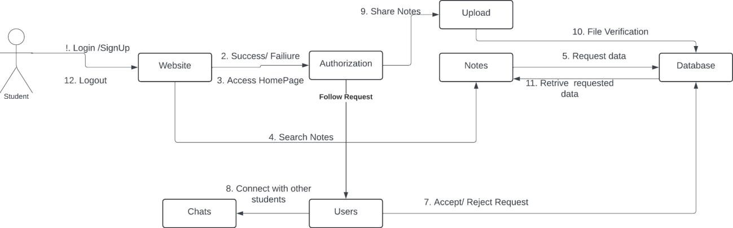

## Sequence Diagram

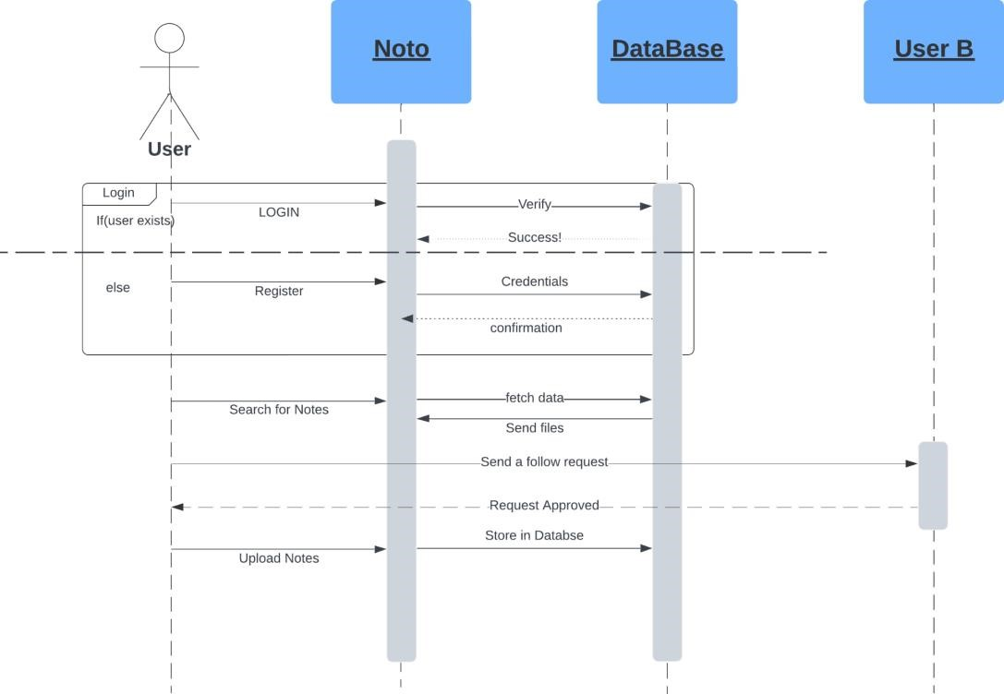

## Entity Relationship Diagram

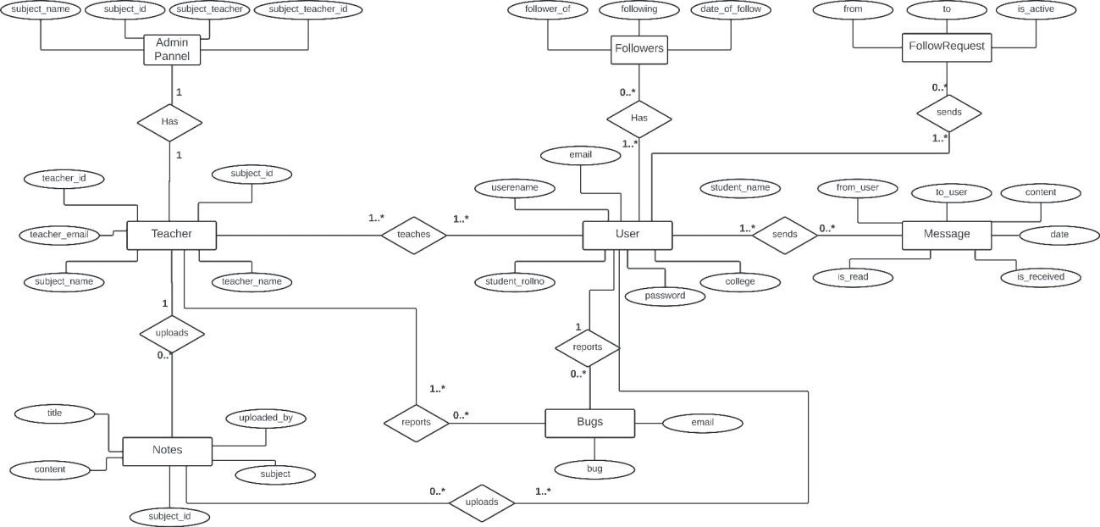

## Data Flow Diagram

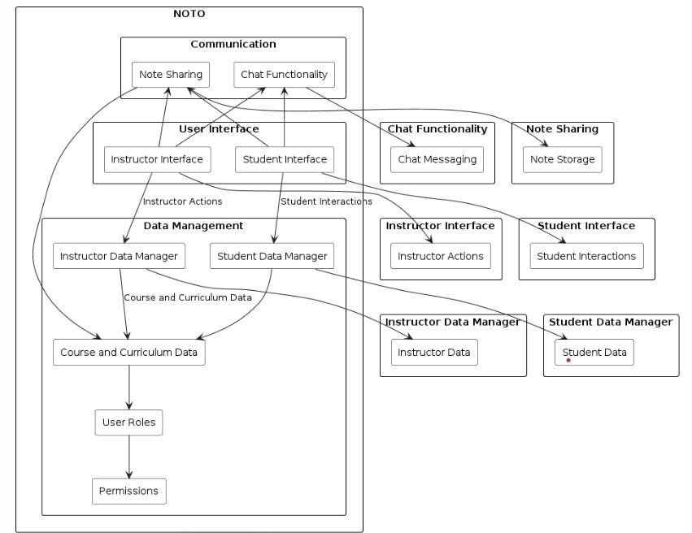

## Project Code Snippets

Functions

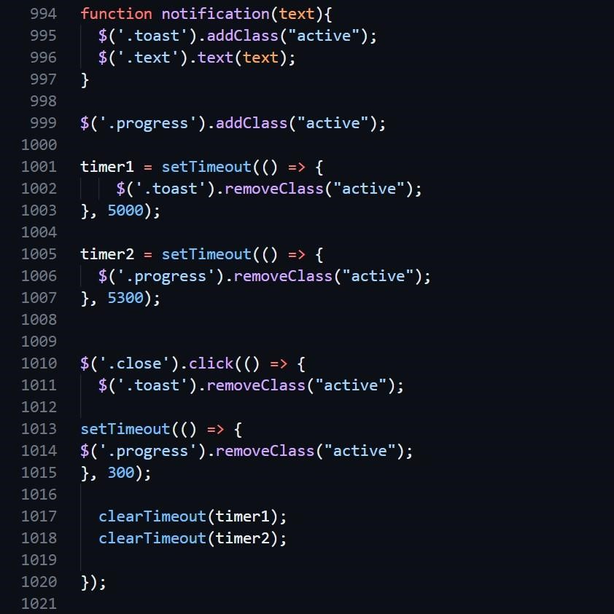

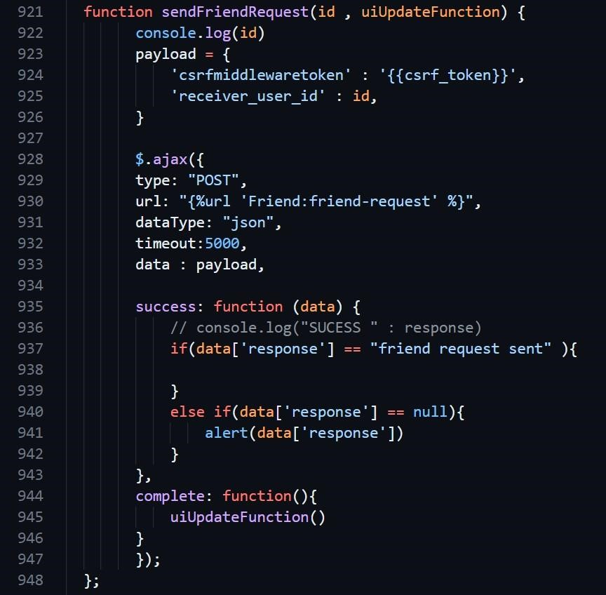

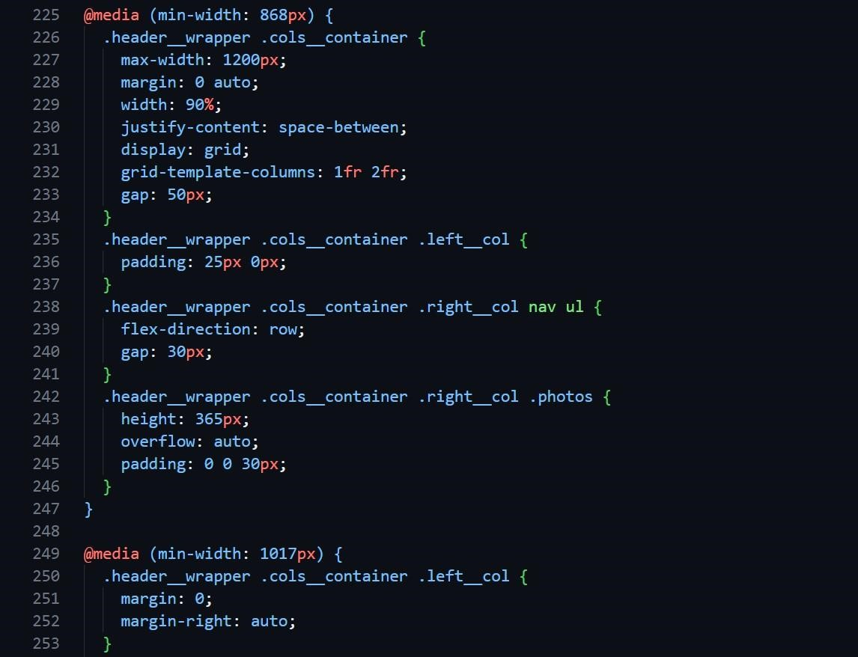

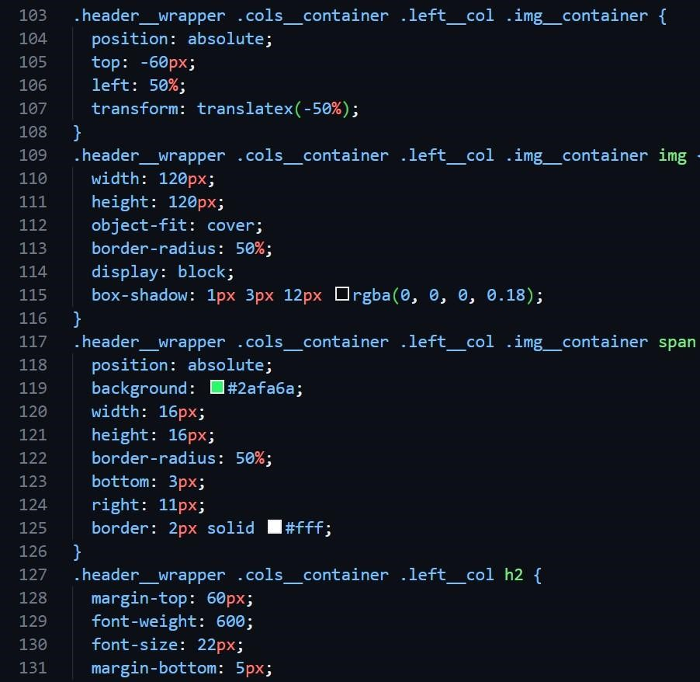

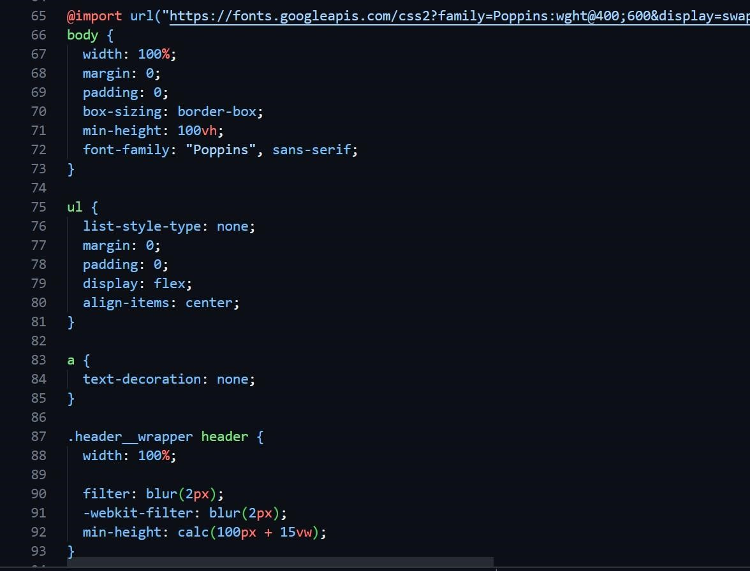

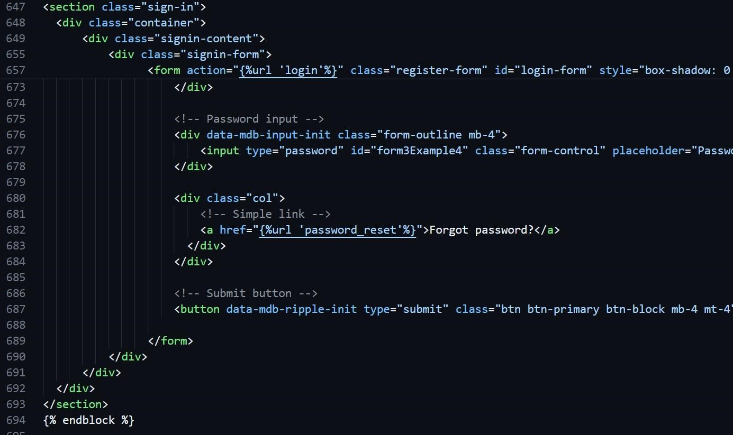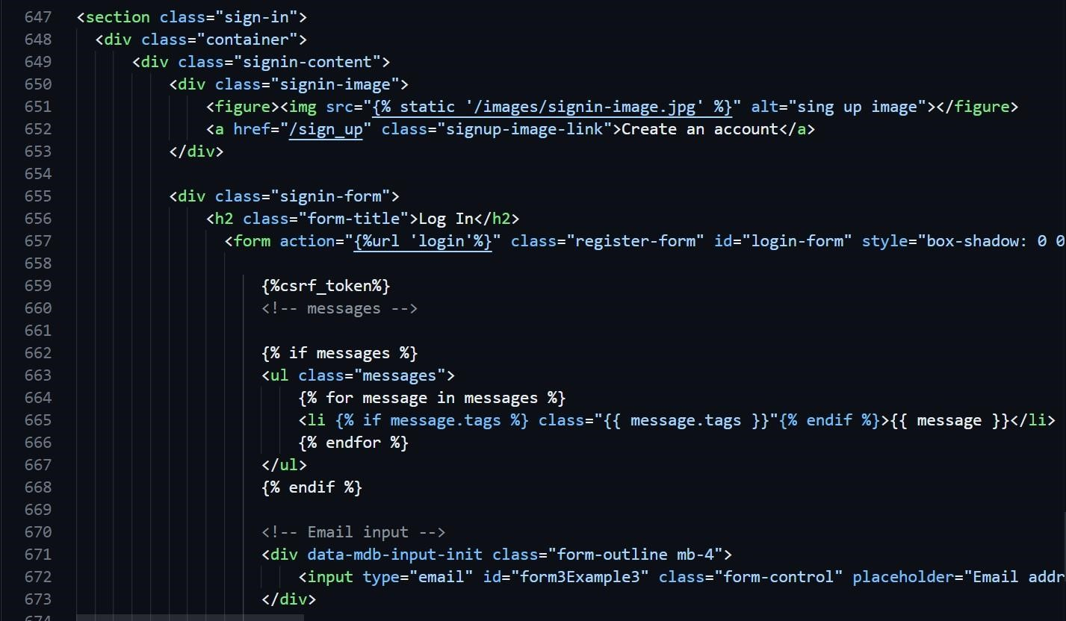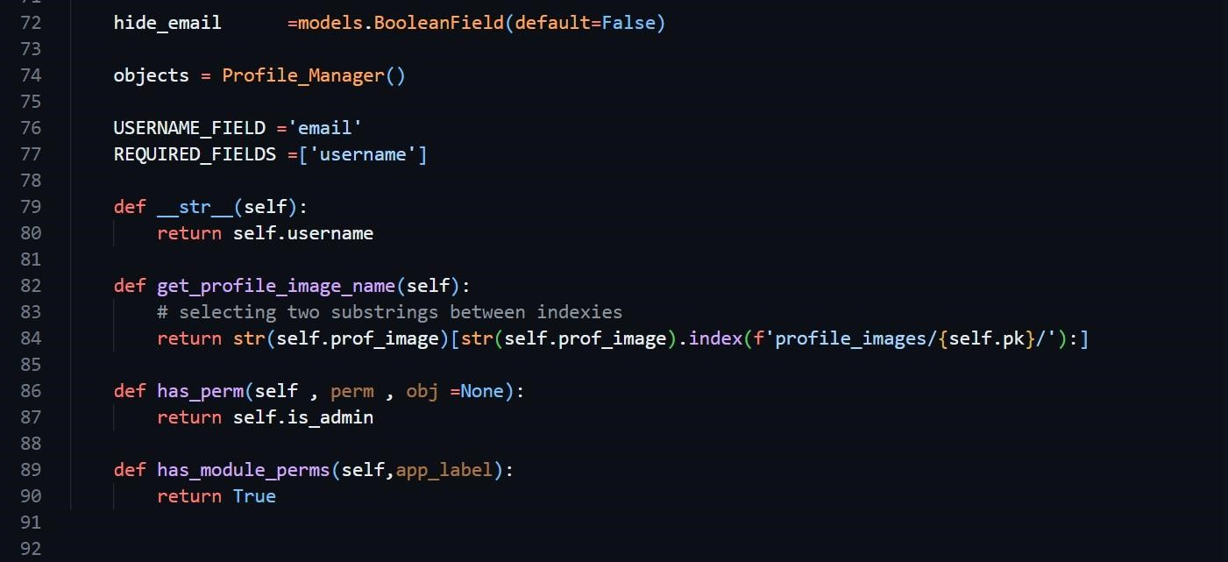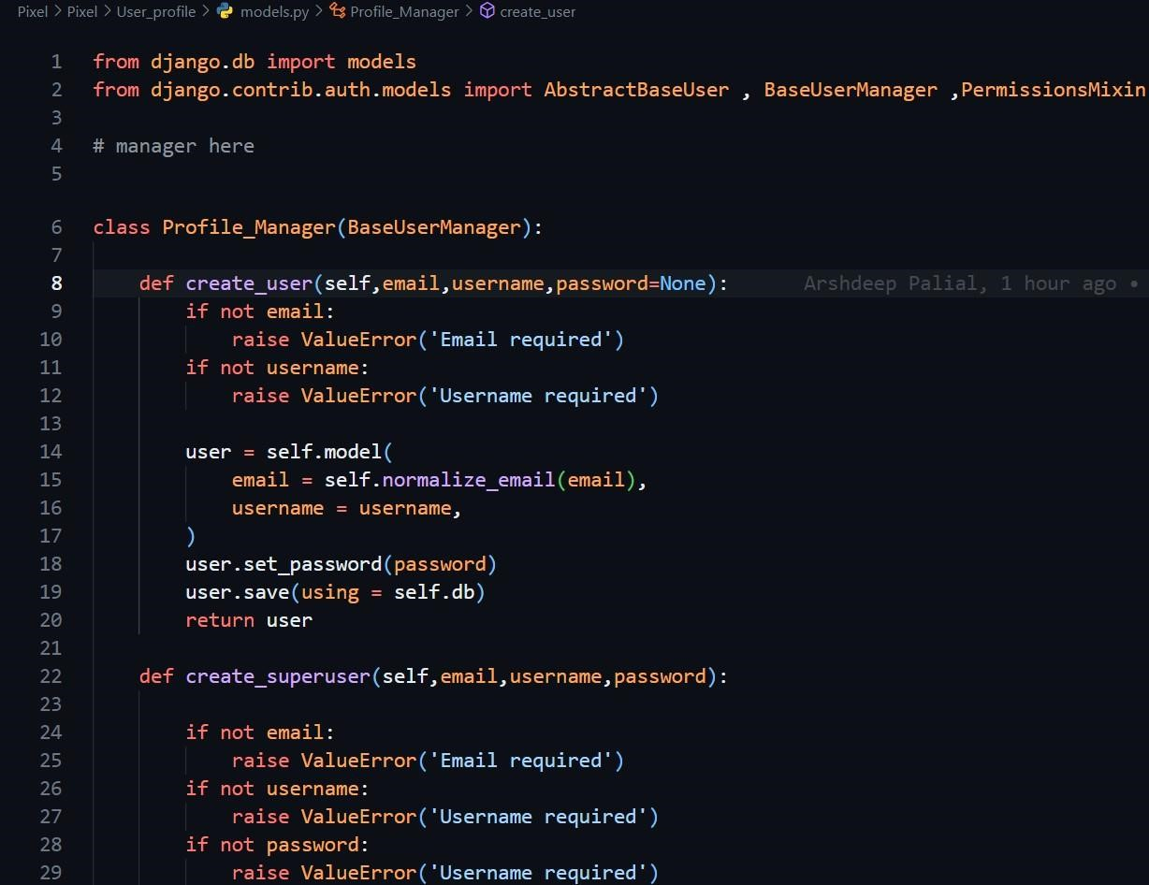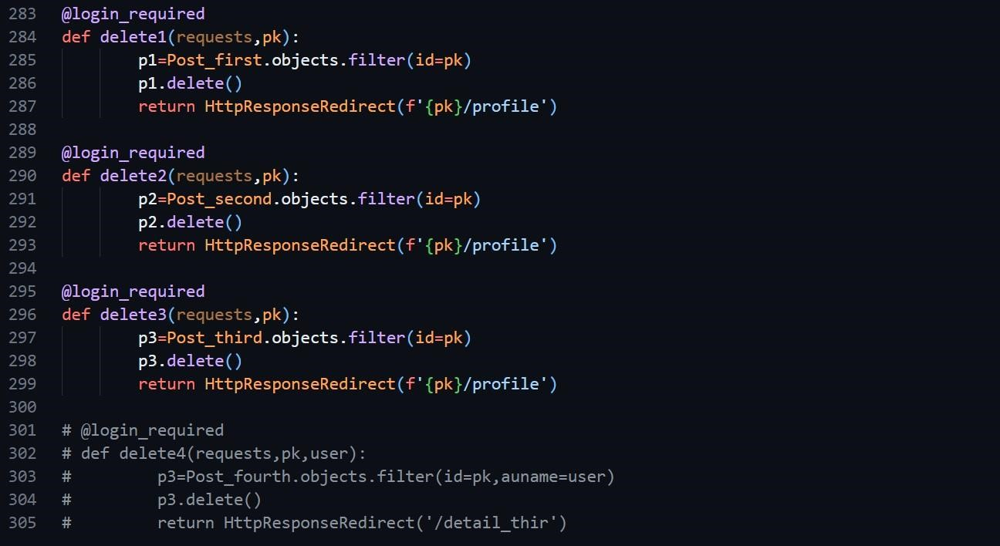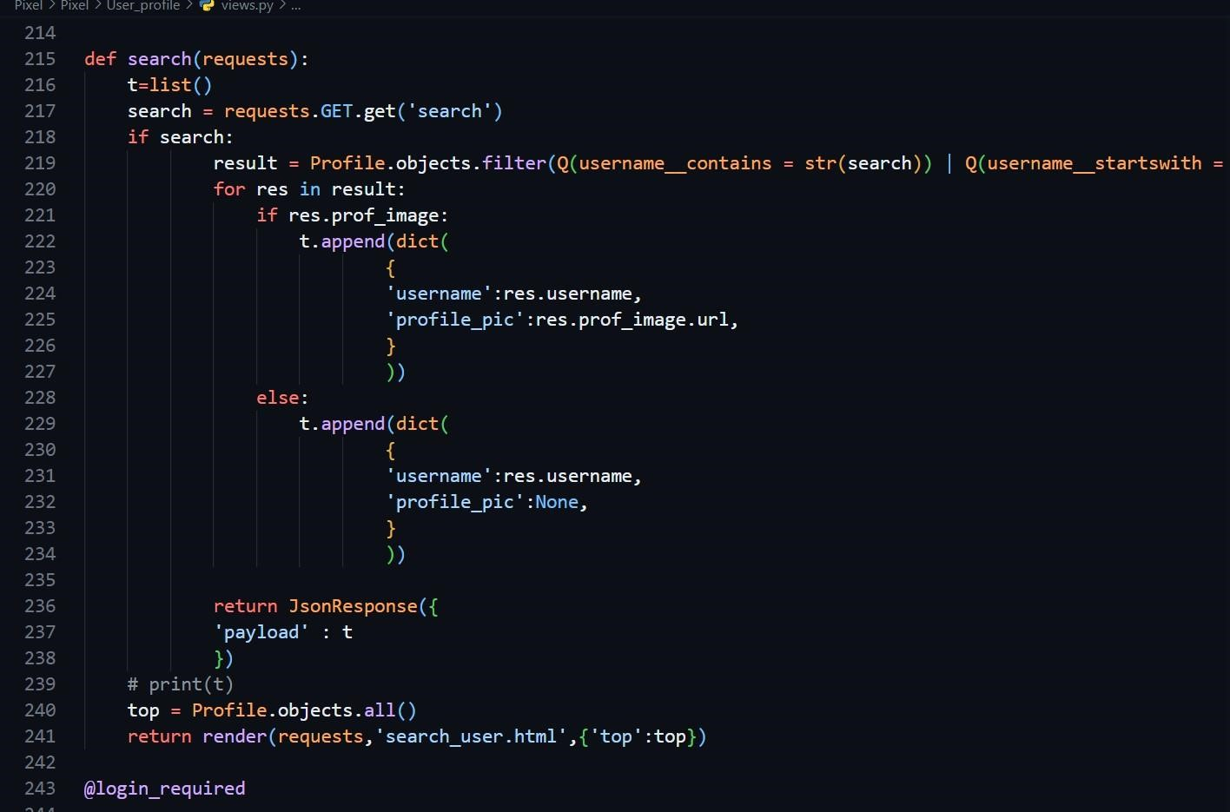

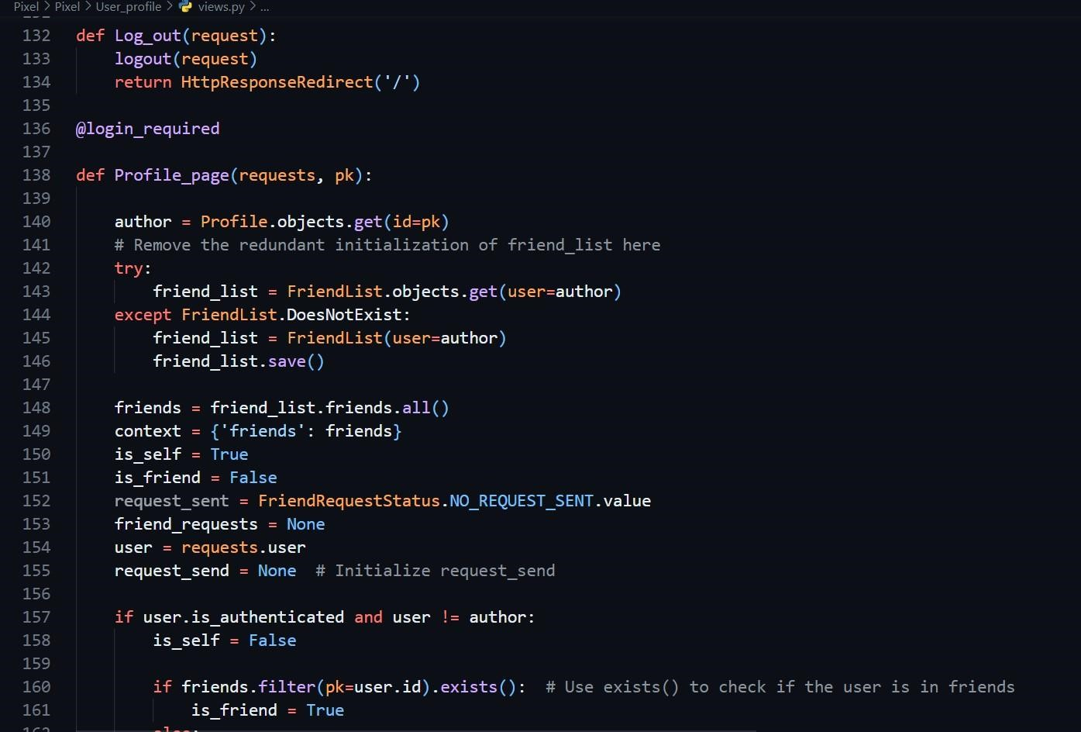

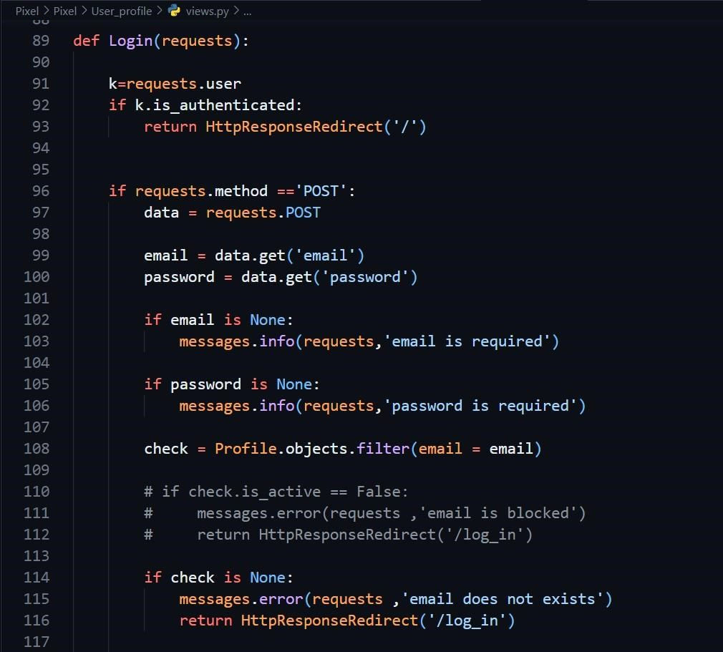

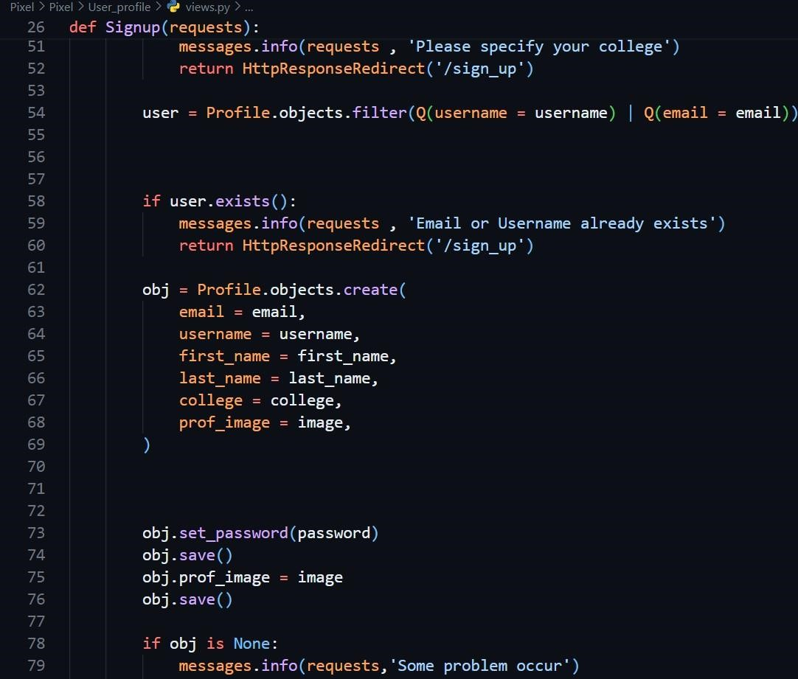

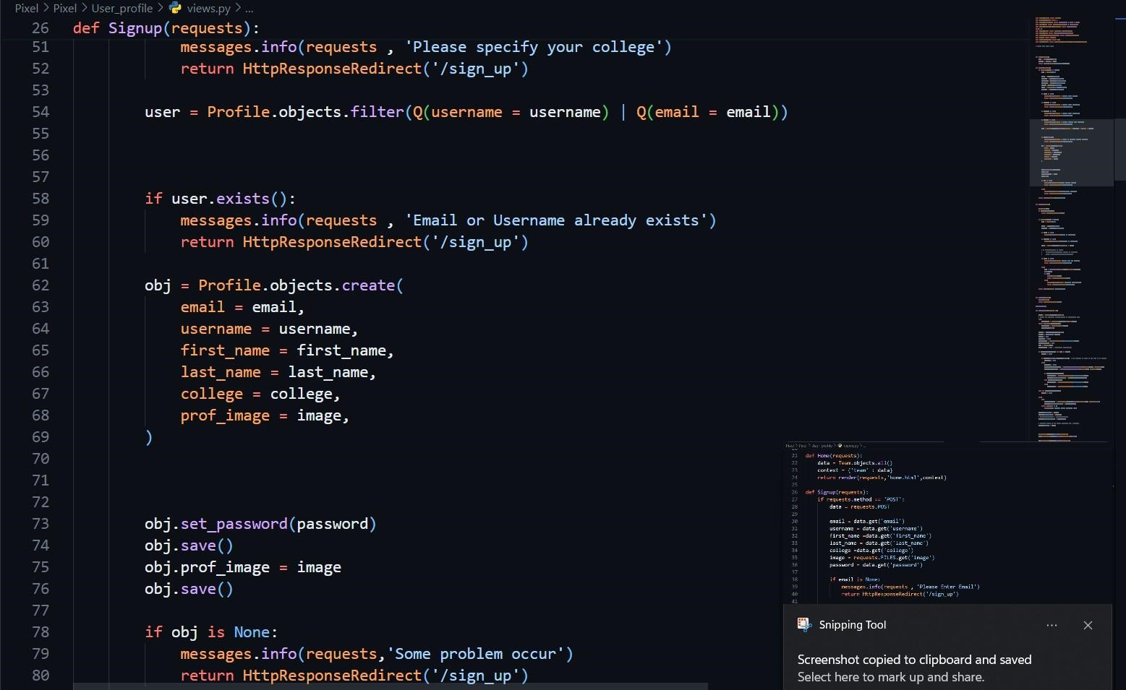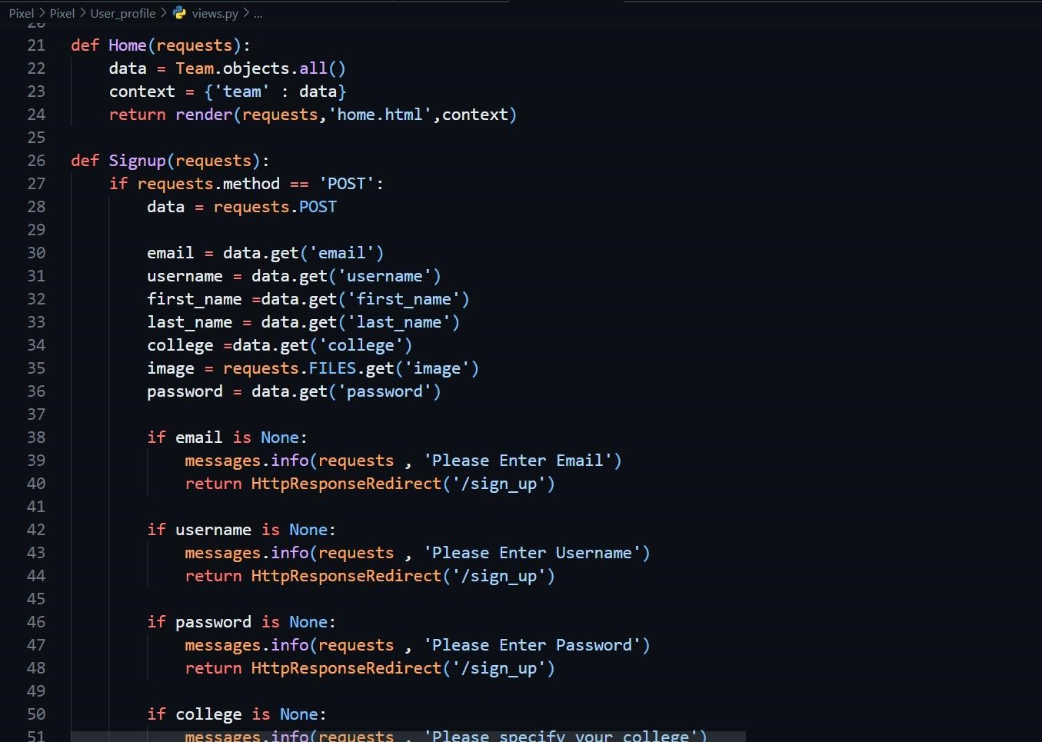

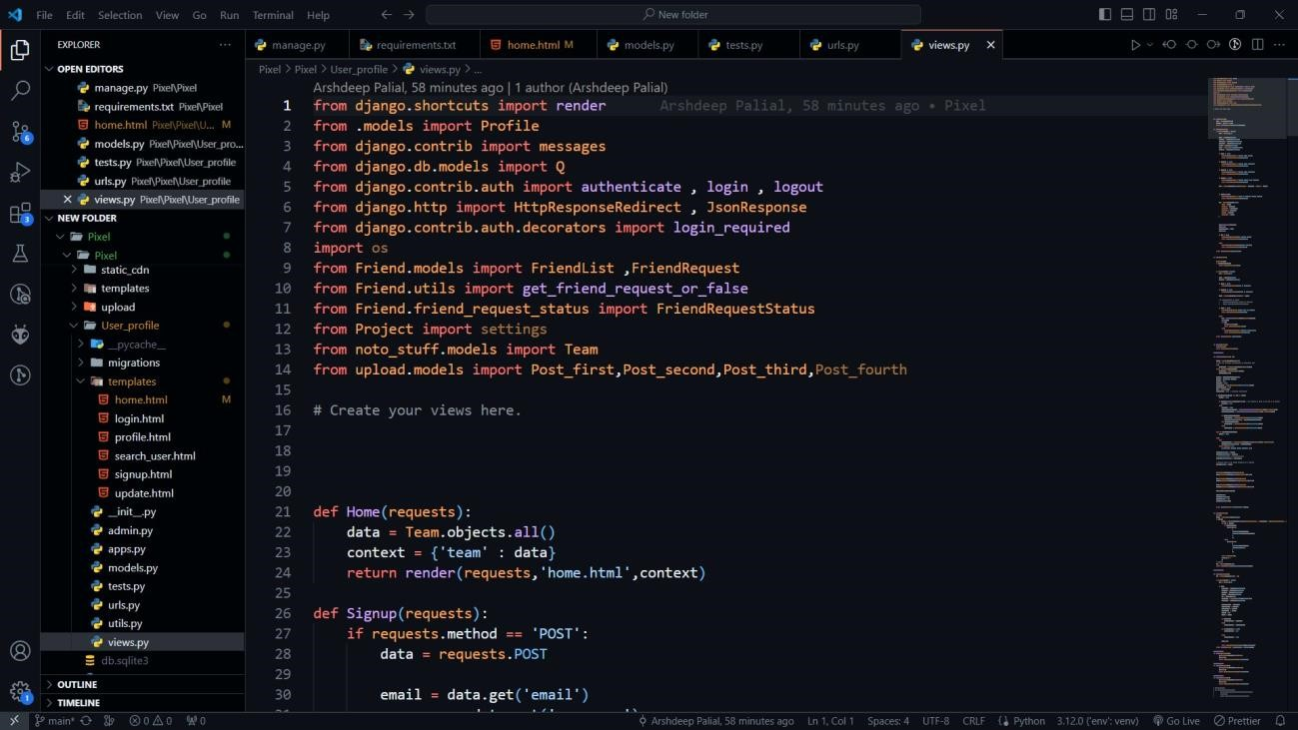

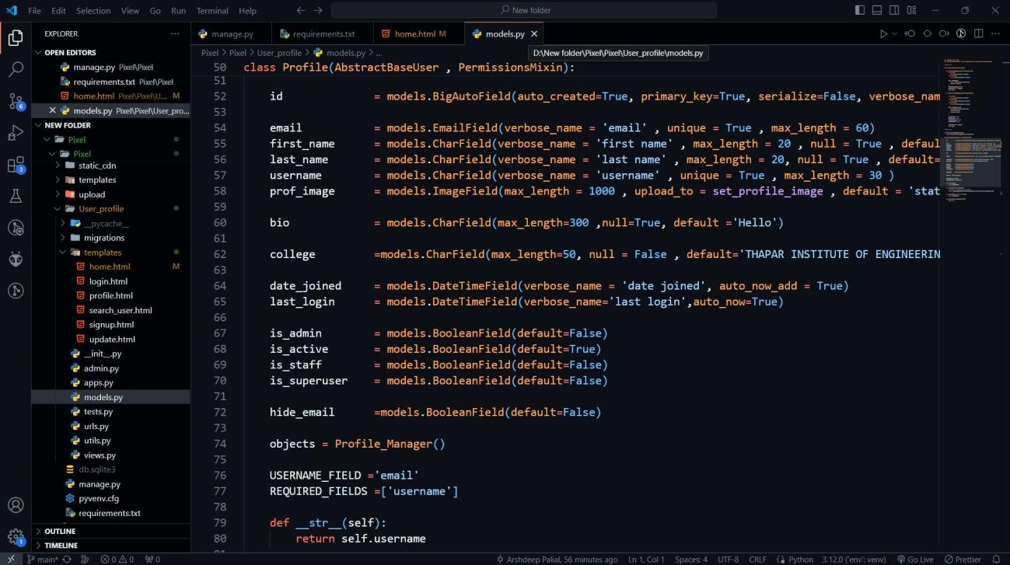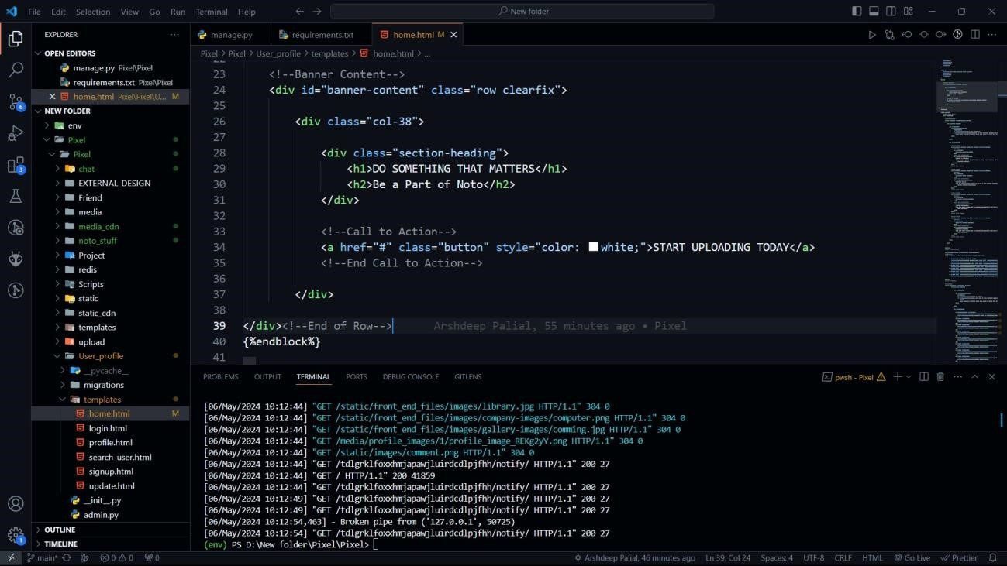

## Final Project Screenshots

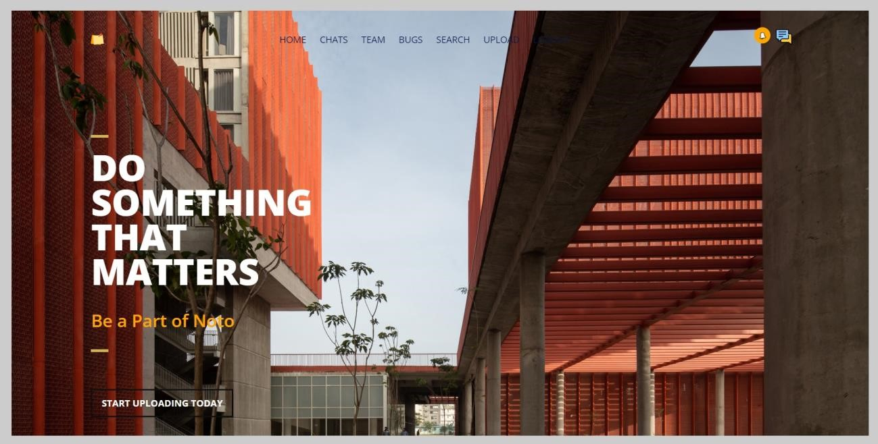

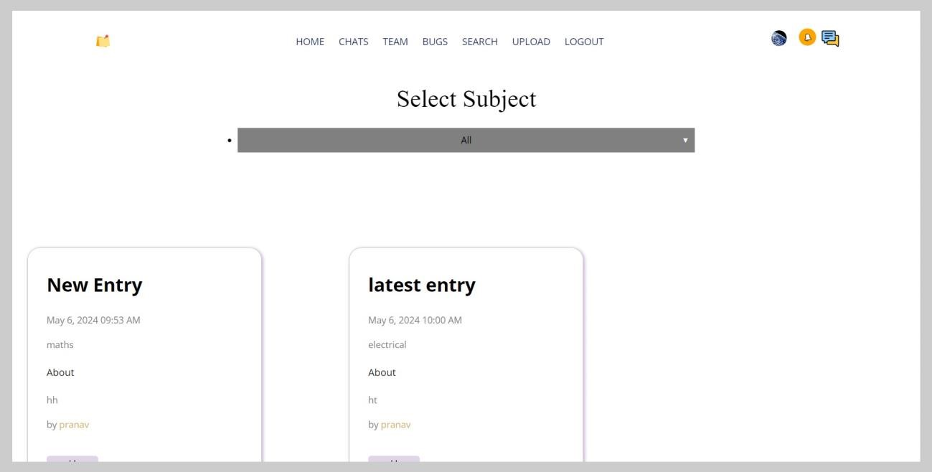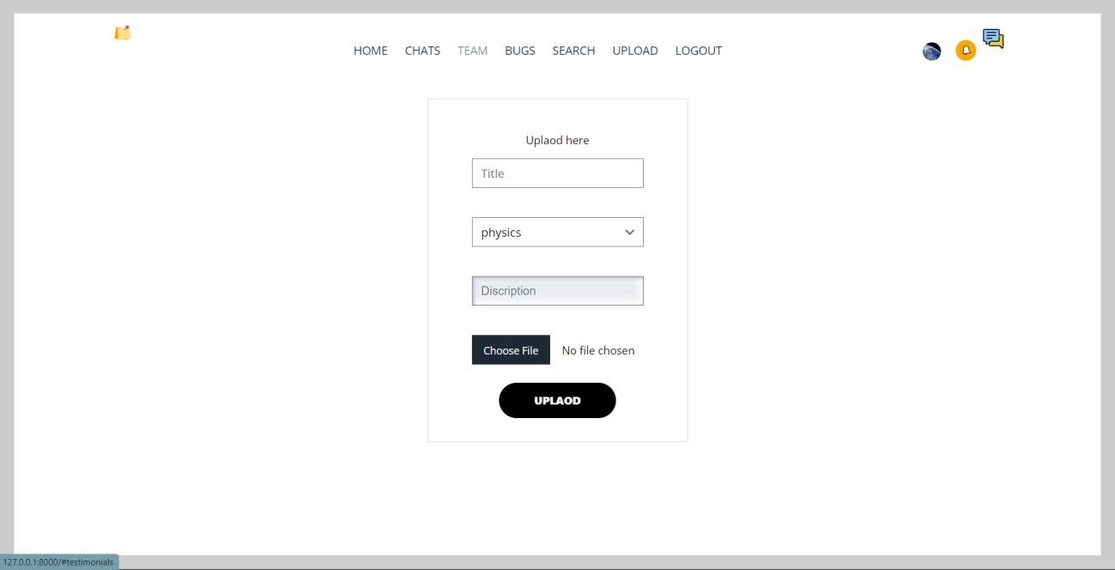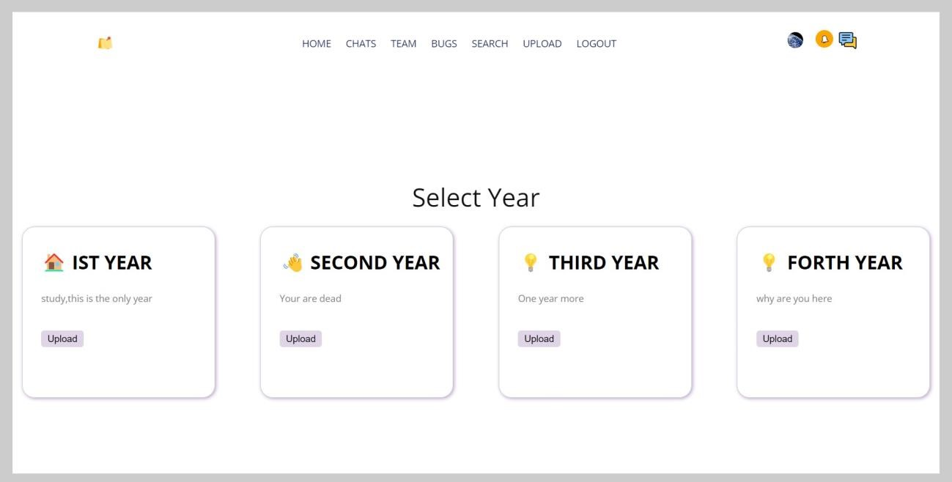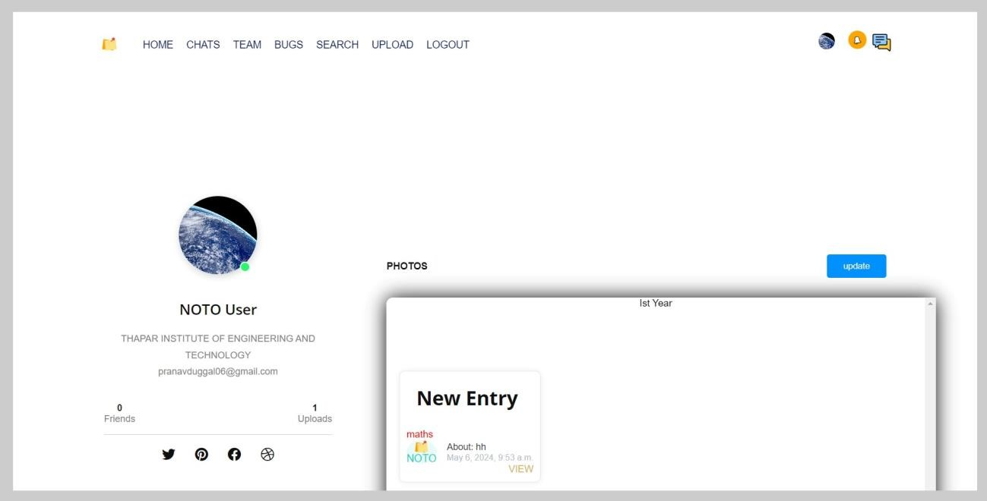

# User Story cards 1

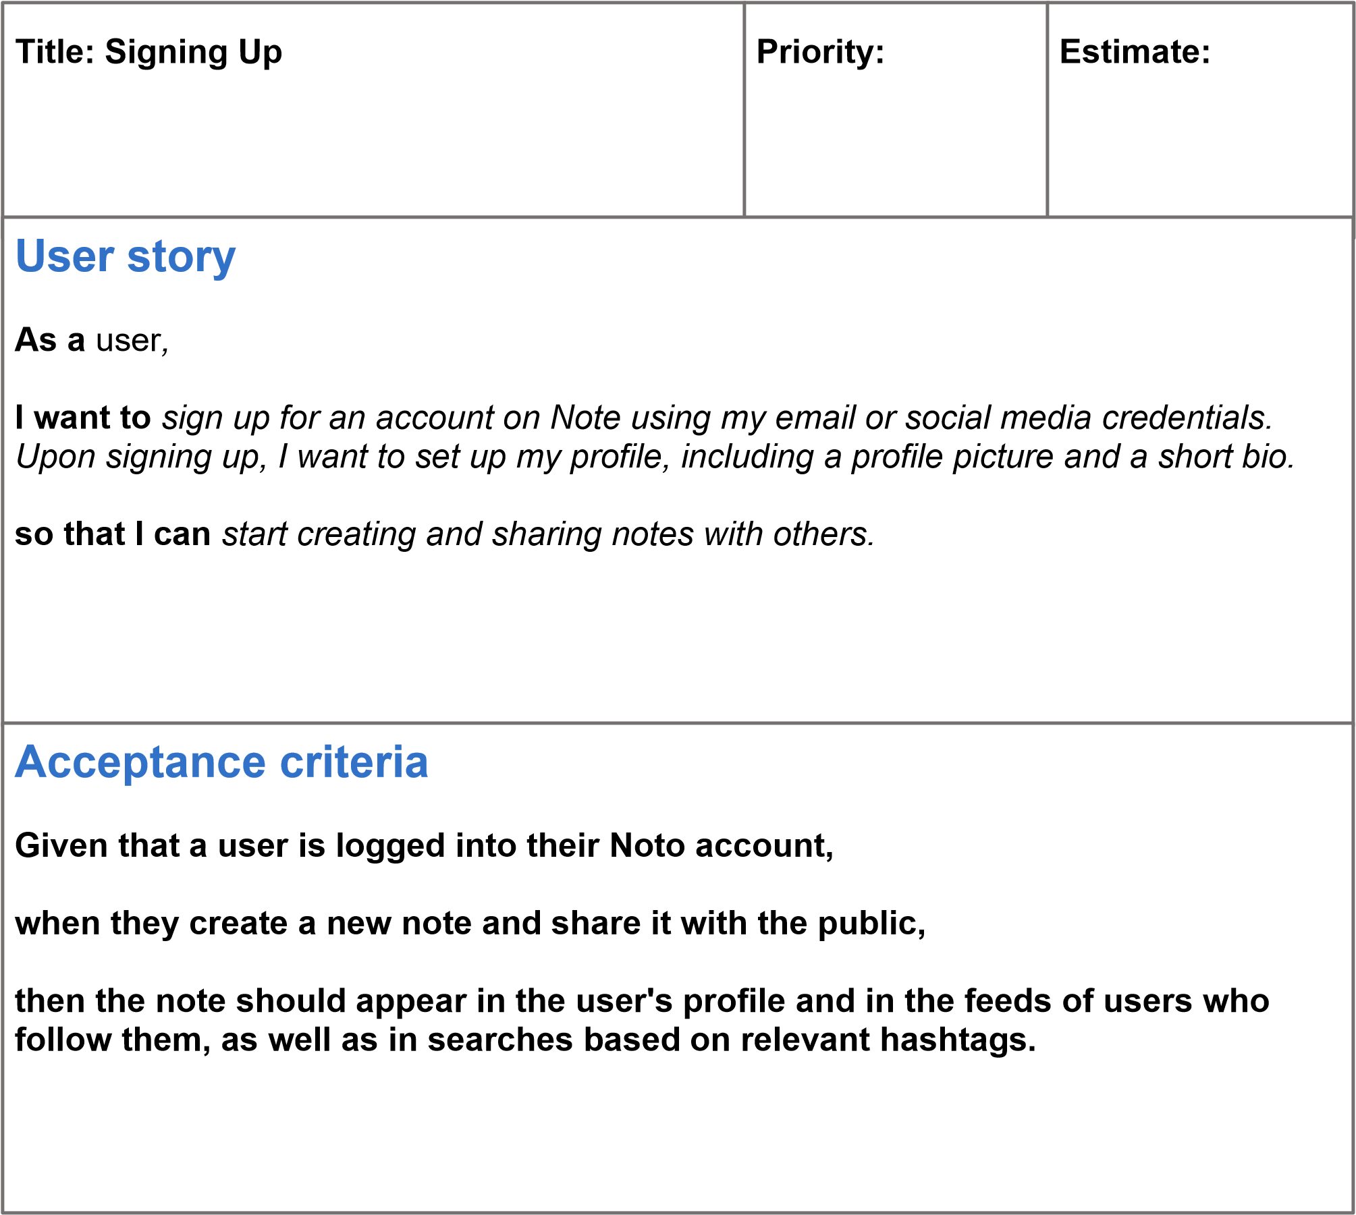

# User Story cards 2

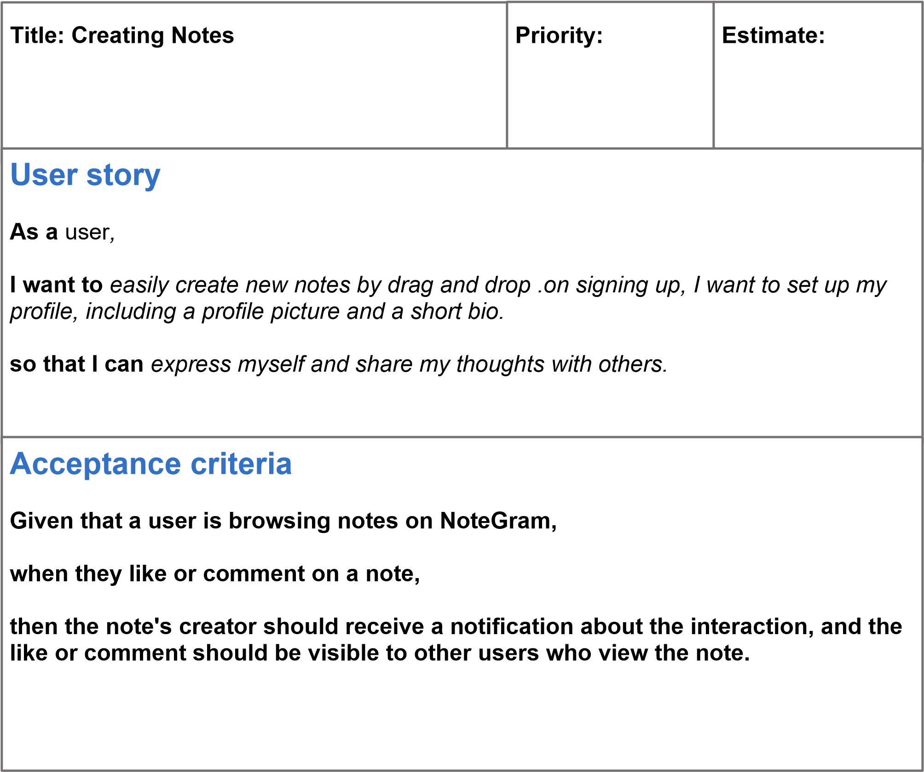

# User Story cards 3

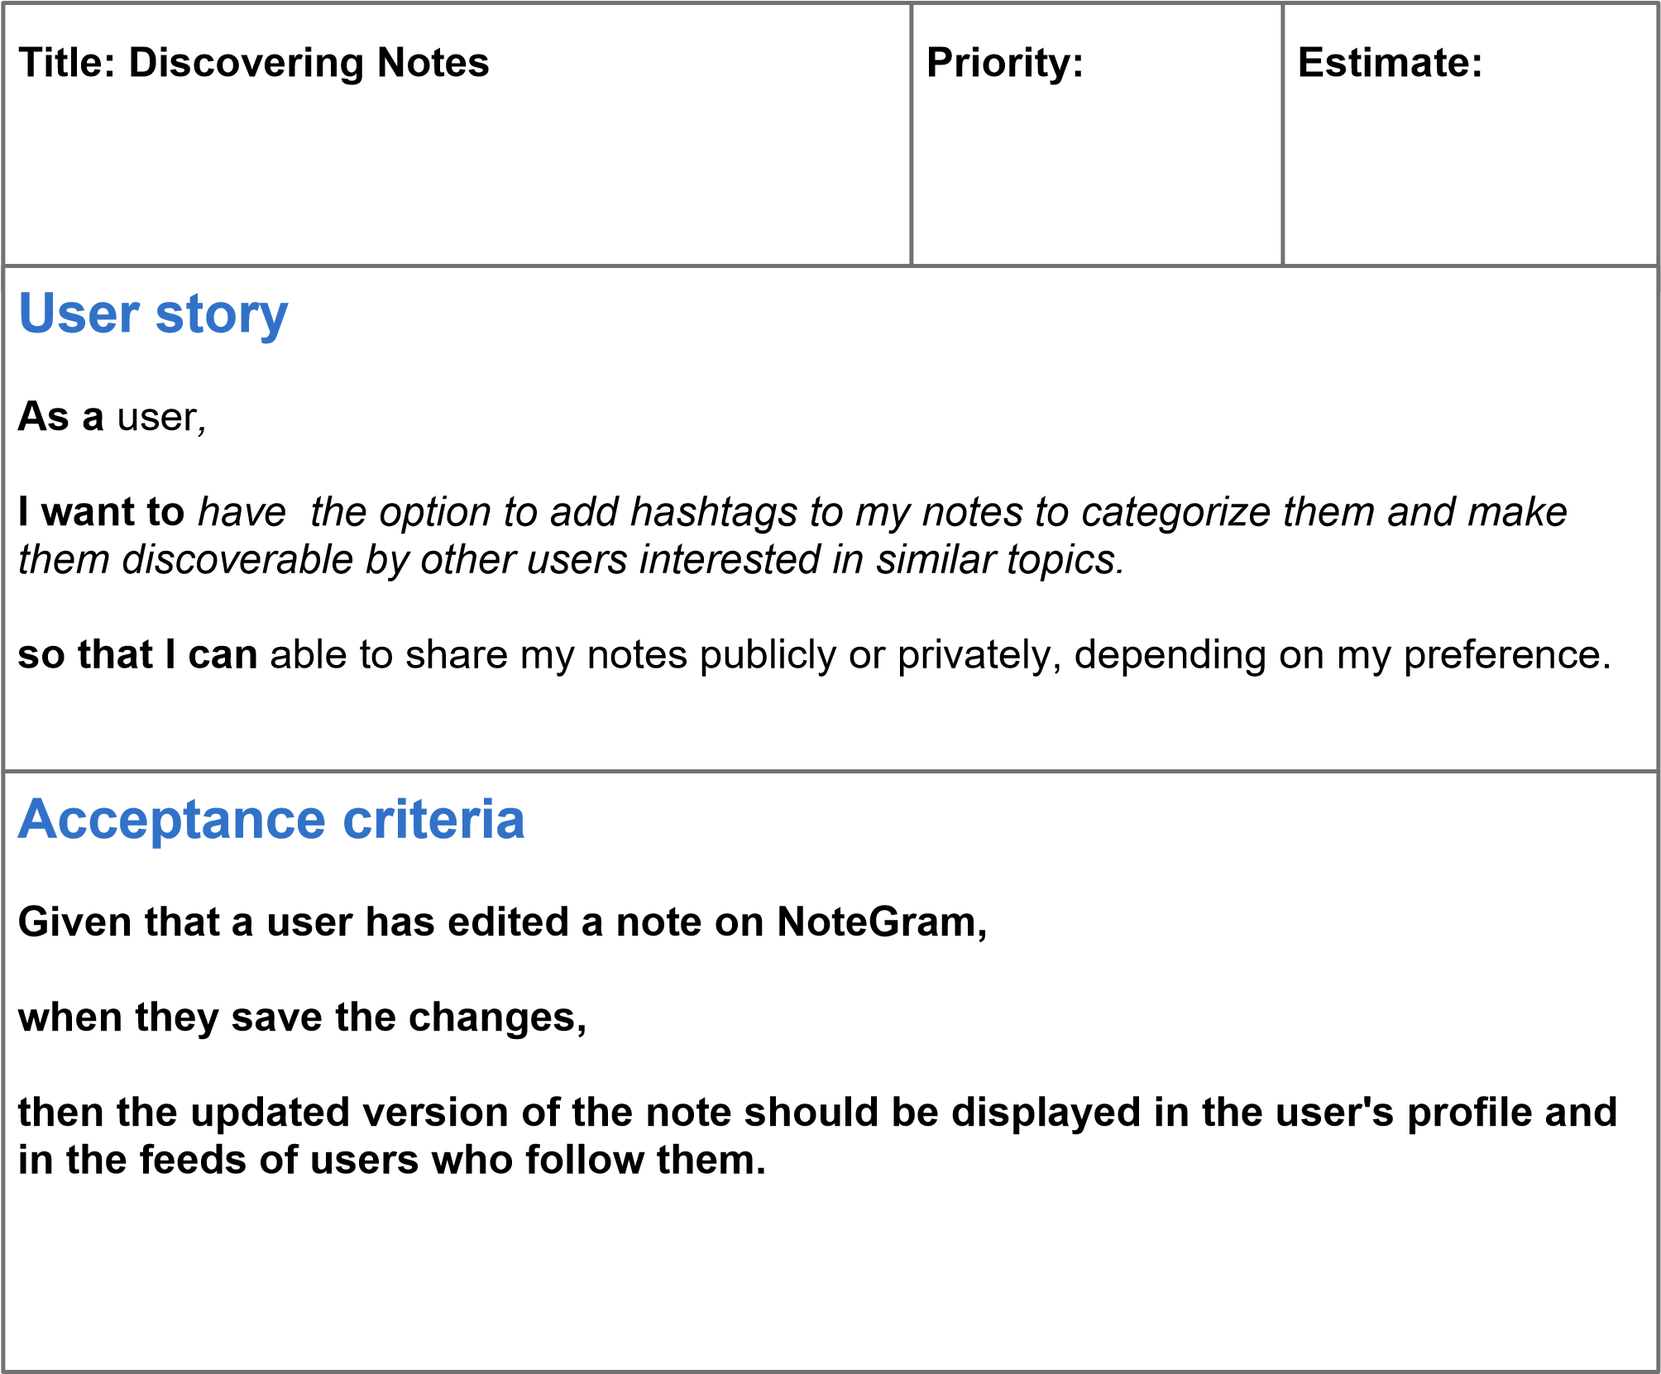

# User Story cards 4

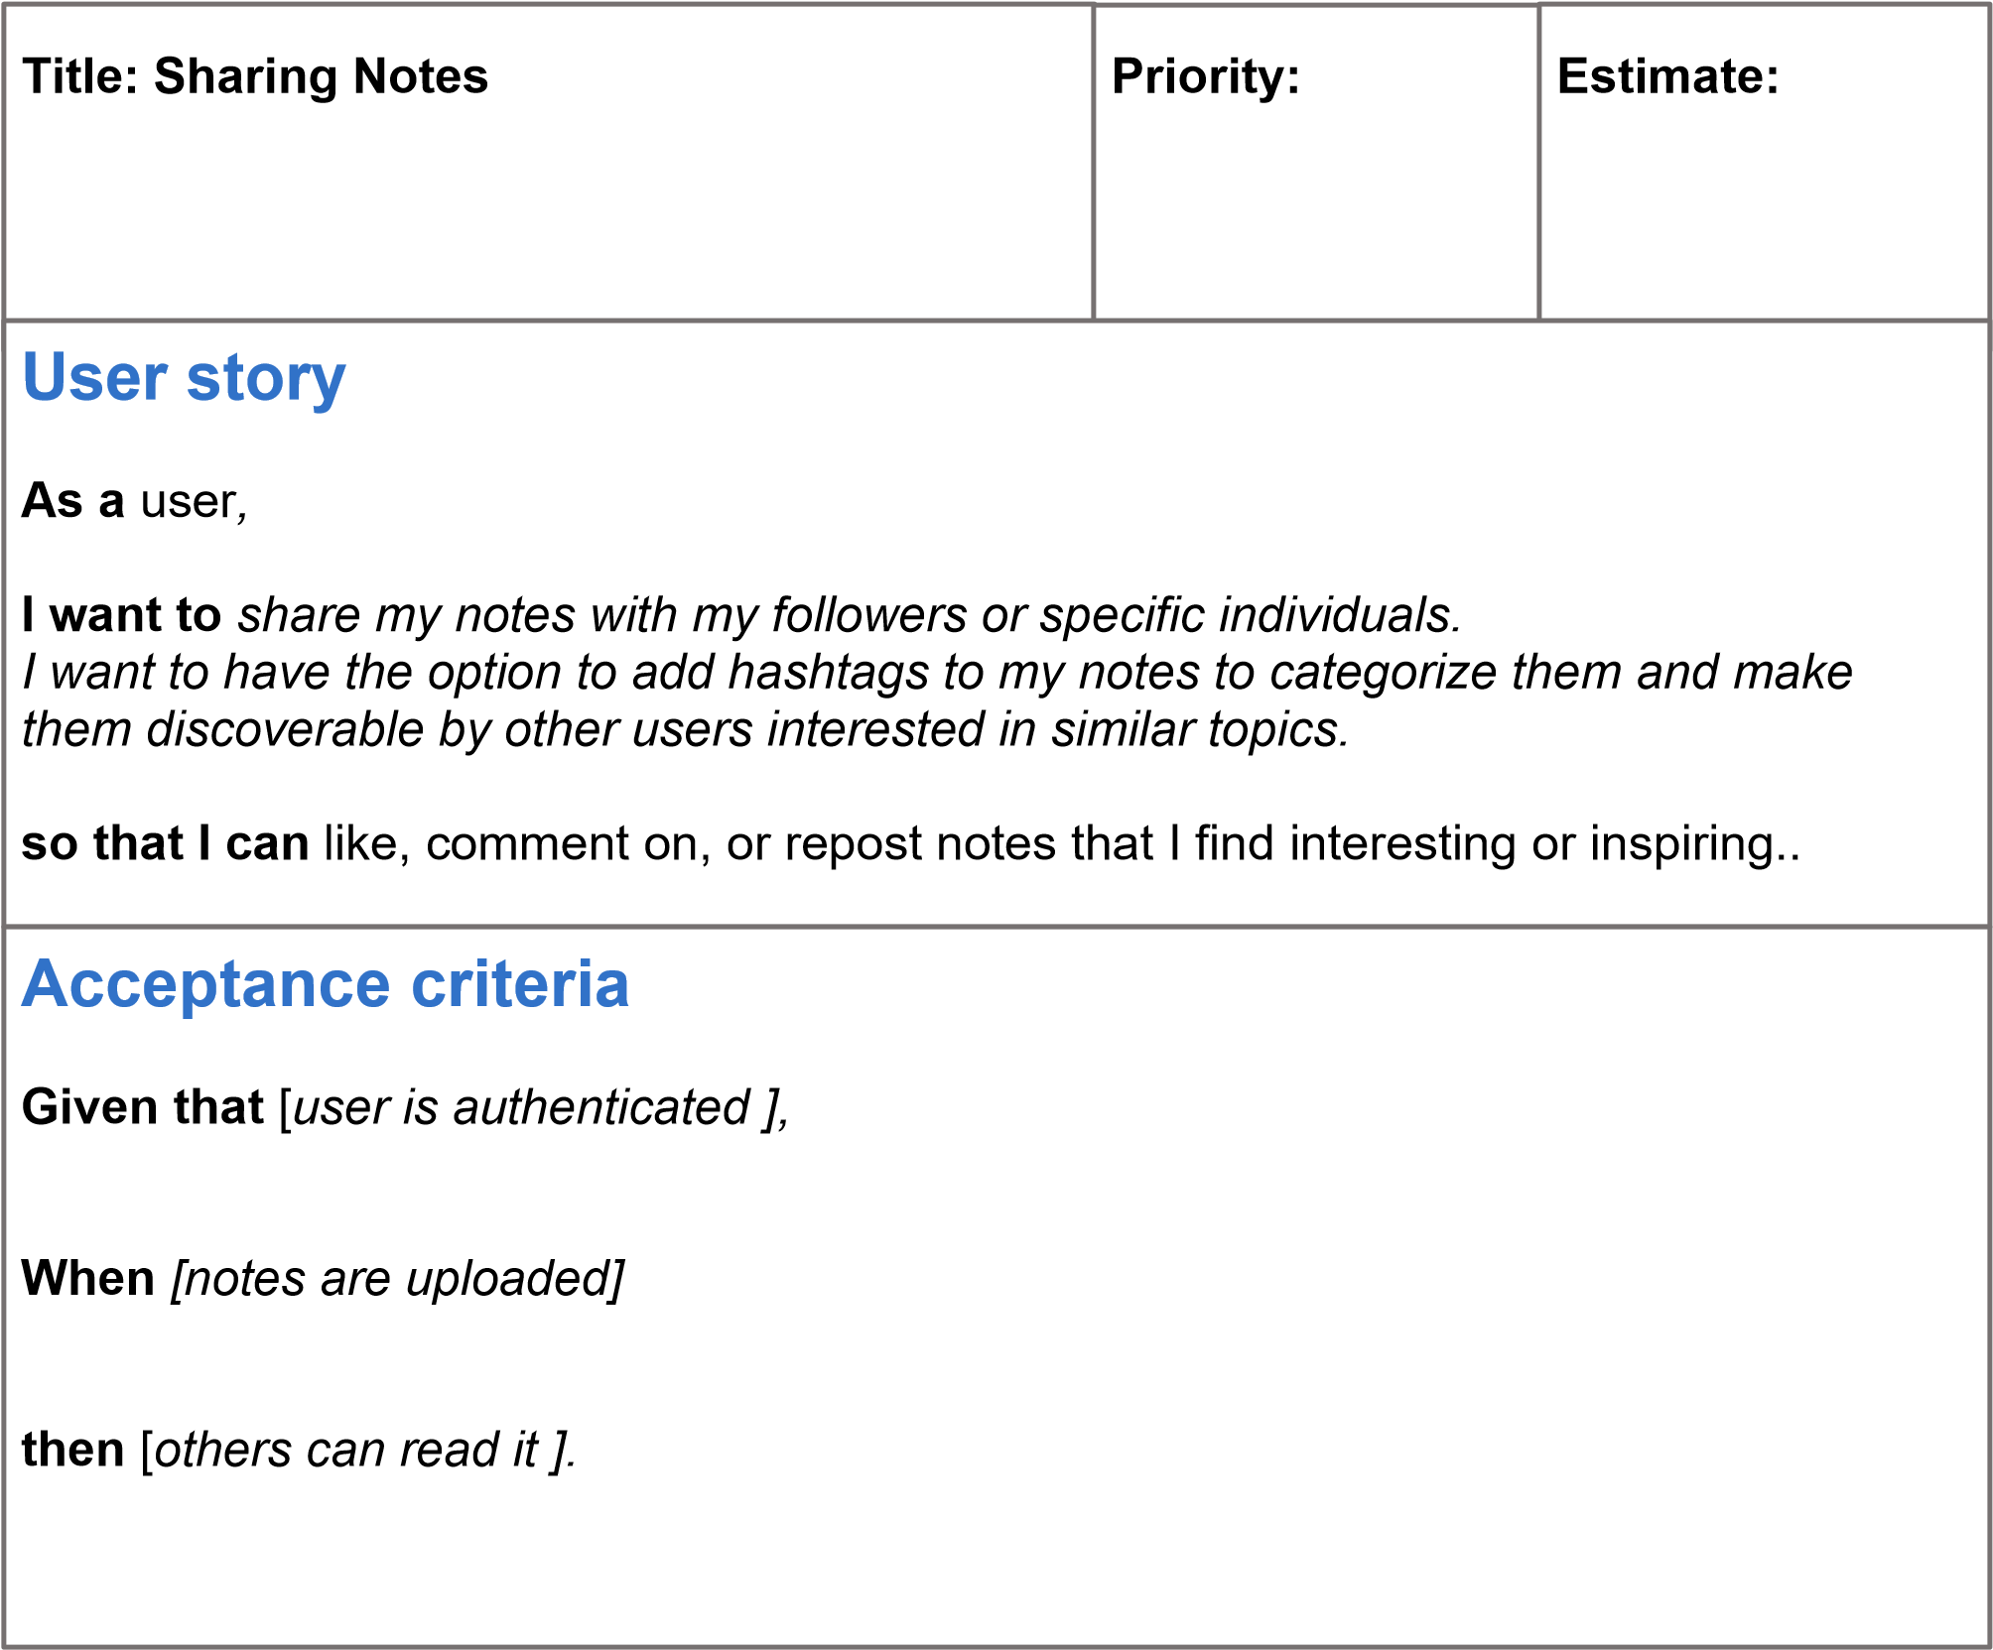

# User Story cards 5



**Title:**

**Privacy**

**and**

**Security**



**Priority:**



**Estimate:**



**User**

**story**

**As**

**a**

user

*,*

**I**

**want**

**to**

*have*

*control*

*over*

*the*

*privacy*

*settings*

*of*

*my*

*notes*

*and*

*profile.*

**so**

**that**

**I**

**can**

block

or

report

other

users

who

engage

in

inappropriate

behavior

.



**Acceptance**

**criteria**

**Given**

**that**

[

*the*

*user*

*is*

*misbehaving*

*]*

*,*

**w**

**hen**

[

*inaproperiate*

*]*

**t**

**hen**

[

*block*

*the*

*user*

*].*

# User Story cards 6

rweg

sdgrgegewfer



**Title:**

**search**

**profile**



**Priority:**



**Estimate:**



**User**

**story**

**As**

**a**

user

*,*

**I**

**want**

**to**

*profiles*

*using*

*username*

*.*

*Upon*

*searching*

*up,*

*I*

*want*

*to*

*see*

*profile*

*with*

*searched*

*username*

*.*

**so**

**that**

**I**

**can**

*start*

*searching*

*and*

*connect*

*with*

*people*

*.*



**Acceptance**

**criteria**

**Given**

**that**

**a**

**user**

**has**

**profile**

**on**

**Not**

**o**

**,**

**when**

**they**

**create**

**a**

**new**

**note**

**and**

**share**

**it**

**with**

**the**

**public,**

**then**

**the**

**note**

**should**

**appear**

**in**

**the**

**user's**

**profile**

**and**

**in**

**the**

**feeds**

**of**

**users**

**who**

**follow**

**them,**

**as**

**well**

**as**

**in**

**s**

**earches**

**based**

**on**

**relevant**

**hashtags.**